
Learner Workbook

Module 2
Mathematical Literacy
US: 9015, 9016, 7468

Further Education and Training Certificate: Information Technology: Technical Support
Qual ID: 78964
NQF LEVEL 4, Worth 165 Credits

Learner Information:

Name & Surname:
ID Number
Tel/Cell
Email Address
Organisation:
Facilitator Name:

Copyright
All rights reserved. The copyright of this document, its previous editions and any annexures thereto, is protected and expressly reserved. No part of this document may be reproduced, stored in a retrievable system, or transmitted, in any form or by any means, electronic, mechanical, photocopying, recording or otherwise without the prior permission.

Learner Workbook Introduction
About | The purpose of this Learner Workbook is to evaluate learners understanding on the specific outcomes and/or assessment criteria of the following SAQA Registered Unit Standards. It has been designed and developed to evaluate learners’ level of understanding of the module: Mathematical Literacy, and forms part of a series of Learner Workbooks that have been developed for the qualification: Further Education and Training Certificate: Information Technology: Technical Support - Qual ID: 78964 NQF LEVEL 4, Worth 165 Credits.
Resources | The following are resources needed for this assessment:  - Learner Guide; and  - Assessment Preparation.
Facilitator’s Responsibility | Facilitators will be required to:  - Explain the completion of the workbook to each learner; and  - Interview the learner on similar questions, should he/she not be able to write
Instructions to the Learners | Learners will be required to:  - Complete the workbook as per the instructions;  - Ensure that all questions are completed;  - Ensure that the completion of the workbook is their own work;  - Ensure that all annexure are attached to the workbook and clearly referred to;
Assessment | Learners are required to complete this assessment within the allocated time frames.
Equipment | Learners are required to have the following equipment in order to complete this workbook:  - Pen and Pencil;  - Ruler; and  - Exam Pad – for additional paper.

Assessment Preparation Checklist

DESCRIPTION |  |  | YES | NO | COMMENTS/CONTINGENCY
This is a formative assessment and it is based on the outlined unit standard/s for the module: Mathematical Literacy.
Your assessment evidence for this module needs to be submitted by the agreed time frames.
You will be assessed based on the outlined Unit Standards, and the assessment activities are linked to specific outcomes/assessment criteria of the outlined Unit Standards.
To determine your competence level, Formative & Summative Assessment methods are to be used.
You will be provided with detailed feedback on your performance of this assessment in the form of written and verbal feedback.
Should you be declared “not yet competent” on this assessment, you will be entitled for re-assessment opportunity/ies, where you will be required to re-submit evidence (only for areas) you were declared not yet competent. A date for re-submission will be agreed with the assessor.
You will be entitled to lodge an appeal should you not be satisfied with the assessment decision of your assessment.
You will be required to provide the assessor feedback on assessment procedure – this is to assist in improving the assessment practices.
Your results of assessment and portfolio of evidence information will not be provided to any person without your written consent.
Learner’s Declaration
I…………………………………………………………………………………………….herewith declare that I am ready for the assessment, that we have reviewed the assessment preparation and plan, I understand the assessment process and I am happy that the assessment will be conducted in a fair manner.
Learner Signature: | Date: | Facilitator Signature: |  |  |  | Date:

Learning Unit 1 | US: 9015, NQF Level 4 Worth 6 Credits  Apply knowledge of statistics and probability to critically interrogate and effectively communicate findings on life related problems
Unit Standard Purpose | This Unit Standard is designed to provide credits towards the mathematical literacy requirement of the NQF at Level 4. The essential purposes of the mathematical literacy requirement are that, as the learner progresses with confidence through the levels, the learner will grow in:  - A confident, insightful use of mathematics in the management of the needs of everyday living to become a self-managing person  - An understanding of mathematical applications that provides insight into the learner`s present and future occupational experiences `and so develop into a contributing worker  - The ability to voice a critical sensitivity to the role of mathematics in a democratic society and so become a participating citizen.  People credited with this unit standard are able to:  - Critique and use techniques for collecting, organising and representing data.  - Use theoretical and experimental probability to develop models, make predictions and study problems.  - Critically interrogate and use probability and statistical models in problem solving and decision making in real-world situations.
Learning Assumed to be in Place | The credit value is based on the assumption that people starting to learn towards this unit standard al-e competent in Mathematical Literacy and Communications at NQF level 3.

 | Complete the following formative activities as per requirements

Activity 1 | Identify 3 situations or issues in your workplace that can be dealt with through statistical methods and in each case say what type of routine statistics you would gather:
  Situation/issue | Type of Statistics
________________________________________________________________________________________________________________________________________________________________________________________________________________________________________________________________________________________________________________________________________________________________________________________________________________________________________________________________________________________________________________________________________________________________________________________________________________________________________________________________________________________________________________________________________________________________________________________________________________________________________________________________________________________________________________________________________________________________________________________________________________________
Activity 2 | Explain how forecasting plays a role in your business unit and organisation:
________________________________________________________________________________________________________________________________________________________________________________________________________________________________________________________________________________________________________________________________________________________________________________________________________________________________________________________________________________________________________________________________________________________________________________________________________________________________________________________________________________
Activity 3 | Read the following article written by the statistician-general of SA, and then answer the questions that follow:  - Explain what is meant by a “trend” (paragraph 1):  - What “trend” has been identified by Stats SA according to this article?  - Explain what is meant by a “series” (paragraph 5). Refer specifically to the series mentioned in the article:  - List the indicators of debt mentioned in the article:  - Explain the difference between a census and a sample:  - You want to undertake a statistical study of absenteeism in your company. Would you take a census or a sample? Give reasons for your answer.  - In order to collect a representative sample from your team/ business unit, how many members would you have to survey? Explain how you arrived at that figure.  - In order to collect a representative sample from your company, how many employees would you have to survey? Explain how you arrived at that figure.
  Civil judgments for debt down 15.8% in first quarter
  June 23, 2005
  By PaliLehohla
  Not all data released by Statistics SA make the headlines. However, some of the less prominent statistical releases contain important insights, which shed light on trends and developments in society as a whole and the economy in particular.
  For example, each month Stats SA releases data on civil cases for debt. This survey, which covers a sample of magistrates' offices, collects information regarding civil cases recorded, civil summonses issued and civil judgments recorded.
  Its provides information on the extent of unpaid debt in South Africa, which is used by the private and public sectors as an indicator of economic performance.
  Each month the survey covers the number of civil cases recorded; the number of civil summonses issued for debt; the number of civil judgments recorded for debt; and the value of civil judgments recorded for debt.
  The most recent data released in this series reports on three periods: the month of March 2005; change over the period March 2004 to March 2005; and change between the first quarter of 2004 compared with the first quarter of 2005.
  In most areas monitored there was a decrease in the indicators of debt. The total number of civil summonses issued for debt in the first quarter of 2005 decreased by 16.4 percent compared with the first quarter of 2004.
  The big contributors to this decrease were summonses issued in respect of money lent (down 6 percentage points), promissory notes (down 2.3 percentage points), "other" services (down 2.3 percentage points), goods sold on open account (down 1.7 percentage points) "other" debts (down 1.7 percentage points) and rent (down 1.4 percentage points).
  Following this pattern, the total number of civil judgments recorded for debt for the first quarter of 2005 decreased by 15.8 percent compared with the first quarter of 2004.
  The contributors to this decrease were civil judgments in respect of money lent (down 5.1 percentage points), promissory notes (down 2.4 percentage points), rent (down 2.2 percentage points), and "other" debts (down 1.8 percentage points).
  The total value of civil judgments recorded for debt for the first quarter of 2005 decreased by 5.3 percent compared with the first quarter of 2004.
  The major contributors to this decrease were civil judgments recorded in respect of promissory notes (down 4.1 percentage points) and "other" debts (down 2 percentage points).
  However, this decrease was slightly counteracted by an increase in civil judgments recorded in respect of professional services (1 percentage point).
  Turning to the month of March this year, 65 406 civil judgments for debt amounting to R521 million were recorded.
  The largest contributors to this amount were civil judgments relating to money lent (R155.3 million, or 29.8 percent), "other" debts (R135 million, or 25.9 percent) and promissory notes (R77.4 million, or 14.9 percent). During this month, 108 302 new civil summonses for debt were issued.
  Comparative data released as at March 2005 show a decline in the number of civil summonses issued for debt between March 2001 and March 2005. Peaking in December 2002 at over 159 000, the March 2005 figure has fallen to just over 108 000.
  The number of civil judgments recorded for debt reached a high of approximately 105 000 in mid-2003, falling to approximately 65 400 in March 2005.
  Today Stats SA releases the latest data on civil cases for debt, which will reflect the position as at April 2005. Although a lesser-known indicator of trends in the economy, this monthly release provides important insights into economic performance.
  PaliLehohla is the statistician-general and head of Statistics SA. For more information on Stats SA and its outputs, including the latest statistics of civil cases for debt, visit www.statssa.gov.za, or contact user services on (012) 310-8600
______________________________________________________________________________________________________________________________________________________________________________________________________________________________________________________________________________________________________________________________________________________________________________________________________________________________________________________________________________________________________________________________________________________________________________________________________________________________________________________________________________________________________________________________________________________________________________________________________________________________________________________________________________________________________________________________________________________________________________________________________________________________________________________________________________________________________________________________________________________________________________________________________________________________________________________________________________
__________________________________________________________________________________________________________________________________________________________________________________________________________________________________________________________________________________________________________________________________________________________________________________________________________________________________________________________________________________________________________________________________________________________________________________________________________________________________________________________________________________________________________________________________________________________________

Activity 4 | Group work (30 minutes):  Choose a topic that relates to your class, e.g. you want to determine the number of people who are in favour of abortion among the class members, or the number of happily married learners, or the education level of the learners in the class, in fact, any topic of your choice. Draw up a questionnaire using the dichotomous key (about five sets of questions), do a quick survey and present your findings to the class:  Topic:  Questionnaire:
  Question | Yes/no | Go to/ completed
  1.
  A.
  B.
  2.
  A.
  B.
  3.
  A.
  B.
  4.
  A.
  B.
  5.
  A.
  B.
______________________________________________________________________________________________________________________________________________________________________________________________________________________________________________________________________________________________________________________________________________________________________________________________________________________________________________________________________________________________________________________________________________________________________________________________________________________________________________________________________________________________________________________________________________________________________________________________________________________________________________________________________________________________________________________________________________________________________________________________________________________________________________________________________________________________________________________________________________________________________________________________________________________________________________________________________________
Activity 5 | Group work (20 minutes):  Draw up a 10-point checklist that will help you determine if a questionnaire meets the criteria as set out in your Learner Guide:
________________________________________________________________________________________________________________________________________________________________________________________________________________________________________________________________________________________________________________________________________________________________________________________________________________________________________________________________________________________________________________________________________________________________________________________________________________________________________________________________________________________________________________________________________________________________________________________________________________________________________________________________________________________________________________________________________________________________________________________________________________________________________________________________________________________________________________________________________________________________________________________________________________________________________________________________________________________________________________________________________________________________
Activity 6 | Likert scale  A survey attempted to evaluate student interest about a range of classroom topics. Students were asked to rank their interest in various potential topics according to this scale:  10 if they felt a topic was very interesting  6 if they felt a topic was above average interest  4 if they felt a topic was below average interest  - if they felt a topic was not worth studying in class  Please note that only four responses were permitted: 10, 6, 4, and 1. Is this an acceptable survey design? Explain your answer:
______________________________________________________________________________________________________________________________________________________________________________________________________________________________________________________________________________________________________________________________________________________________________________________________________________________________________________________________________________________________________________________________________________________________________________________________________________________________________________________________________________________________________________________________________________________________________________________________________________________________________________________________________________________________________________________________________________________________________________________________________________________________________________________________________________________________________________________________________________________________________________________________________________________________________________________________________________
Activity 7 | When interviewing your team for the purposes of a survey, do you think that there could possibly be bias from either your side or their side? Discuss possible reasons for the bias, based on the information in the Learner Guide. Add any other causes of bias that you may be aware of.
____________________________________________________________________________________________________________________________________________________________________________________________________________________________________________________________________________________________________________________________________________________________________________________________________________________________________________________________________________________________________________________________________________________________________________________________________________________________________________________________________________________________________________________________________________________________________________________________________________________________________________________________________________________________________________________________________________________________________________________________________________________________________________________________________________________________________________________________________________________________________________________________
Activity 8 | Here are the test scores of a class of learners:  100, 100, 99, 98, 92, 91, 91, 90, 88, 87, 87, 85, 85, 85, 80, 79, 76, 72, 67, 66, 45  - What is the average score (mean) of the class for this test?  - Is the sequence written in ascending or descending order?  - Determine the median score  - James obtained a mark of 90 and Petrus obtained a mark of 79 for the test. How would you describe their results in relation to the mean?  - In order to get a better idea of how a given data point relates to other data, it is important to get an idea of how spread out the data are. One way of doing this is by using the range. The range is the distance between the highest and lowest data points in a set. What is the ‘range’ of the scores for this test?
________________________________________________________________________________________________________________________________________________________________________________________________________________________________________________________________________________________________________________________________________________________________________________________________________________________________________________________________________________________________________________________________________________________________________________________________________________________________________________________________________________________________________________________________________________________________________________________________________________________________________________________________________________________________________________________________________________________________________________________________________________________
Activity 9 | Group work (15 minutes): Find out how old each learner in the class is  Planning phase:  - First decide on the quickest and most effective way to obtain the required information  - How can you ensure that the information is accurate and representative?  Obtain and sort data: Calculate the average age (mean) of the learners in this class.  Calculate the median of the ages of all the learners. Show the sequence in ascending order:  Analyse data: What conclusions can you reach based on the data?  Reflect on the process you followed to obtain the information:  - Was it effective?  - Were respondents cooperative?  - What would you do differently next time?
______________________________________________________________________________________________________________________________________________________________________________________________________________________________________________________________________________________________________________________________________________________________________________________________________________________________________________________________________________________________________________________________________________________________________________________________________________________________________________________________________________________________________________________________________________________________________________________________________________________________________________________________________________________________________________________________________________________________________________________________________________________________________________________________________________________________________________________________________________________________________________________________________________________________________________________________________________________________________________________________________________________________________________________________________________________________________________________________________________________________________________________________________________________________________________________________________________________
Activity 10 | Draw a reasonably accurate pie chart by hand based on the following data:  - Absenteeism due to transport problems 108º  - Absenteeism due to illness 162º  - Absenteeism due to training 45º  - Absenteeism due to family commitments 45º  Give your chart a title that accurately reflects the kind of data represented;  Title: ______________________________________________________________________  Legend:_______________________________________________________________  Give an example of the type of data in the workplace that you would represent with:  - a bar chart,  - a line chart and  - a scatter diagram:
__________________________________________________________________________________________________________________________________________________________________________________________________________________________________________________________________________________________________________________________________________________________________________________________________________________________________________________________________________________________________________________________________________________________________________________________________________________________________________________________________________________________________________________________________________________________________
Activity 11 | Read the following article written by the statistician-general of SA, paying particular attention to his explanation of the limitations of statistical information, and then answer the questions that follow:  - Explain how the representative sample has grown from 4.7 million (STEE findings) to 6.559 (SEE) to the current 7.075 million (QES findings):  - What categories of workers have been excluded from QES and why?  - Information regarding employers, employees and the self-employed is obtained by conducting surveys:  - What is the frequency of these surveys?  - Why should they be conducted frequently?  - What is the size of the sample?  - Do you think that it is a representative sample? Give a reason for your answer.  - What are some of the problems regarding choosing a sample of this nature?  - What are the limitations of a time series that has only two data points?  (par.14)?
  New employment survey makes three improvements
  By PaliLehohla
  This article was originally published in the Business Report on 07 July 2005
  Statistics SA continues to improve the quality of its statistics. The quarterly employment statistics (QES) survey was published for the first time on June 28. This survey replaces the quarterly survey of employment and earnings (SEE) which in turn replaced the survey of total employment and earnings (STEE).
  There are important differences between these surveys, all aimed at improving the quality of the information. First, the STEE was drawn from the initial business address register, which was not based on the comprehensive taxation database that the current surveys are based on. It reported formal employment in the non-agricultural sector of 4.7 million people.
  Second, the recently introduced QES covers all employing enterprises in the formal non-agricultural business sector registered for income tax, whereas the SEE was restricted to enterprises registered for VAT, with an annual turnover of R300 000 or more.
  The increase in the coverage of businesses in the QES results in extensive coverage of the formal labour market, as most small businesses are now included in the estimates as well.
  For the quarter to December 2004, the SEE reported employment of 6.559 million people, compared with the estimate of 7.075 million in the QES.
  Third, the definition of employees has been brought in line with International Labour Organisation (ILO) definitions and concepts. Previously, the SEE included working proprietors and own account workers in the estimates of employment, in addition to the employees of an enterprise. This did not allow for the meaningful calculation of estimates for average monthly earnings of employees.
  However, the QES restricts the coverage to employing businesses only, therefore excluding working proprietors in the estimates. It is therefore now possible to provide estimates for employment and earnings as well, as the survey is in accordance with ILO definitions and recommendations.
  The SEE and the QES are not comparable because of these improvements. The estimates for employment for the quarter to December, published on June 28 in the QES, show a difference of about 500 000 employees. This was largely due to the extended coverage of the QES survey, made possible by improvements to the business frame that I reported on in earlier articles.
  The drop in employment in the first quarter was largely caused by seasonal factors, with many people being employed for the December period only. The published results do not take this seasonality into account as it is not possible to develop seasonally adjusted estimates for a series that has only been published for two periods.
  As the series progresses and more results become available, it will become possible to get a clear insight into the labour market by using the QES survey estimates.
  Furthermore, the major contributors to differences in employment levels between the QES for December and the SEE for December are the financial intermediation, insurance, real estate and business services industry, up about 40 percent; the construction industry, up about 30 percent; and the transport, communication and storage industry, up about 50 percent. These increases are mainly due to the QES survey's coverage of small businesses in these industries. The SEE did not cover many of these small businesses.
  Information regarding employers, employees and the self-employed can be obtained from the six-monthly labour force survey, conducted among 30 000 households countrywide. The results of this survey should be read in conjunction with those of the QES, as they all inform on the dynamics in the labour market.
  Over time, by using register-based frames, Stats SA has continued to provide a more representative picture of the economic and the population dynamics of the country.
  The underlying purpose of statistics is to inform users and policy, and statistics should not be misconstrued to suit specific situations. Extreme caution should be exercised when commenting on a time series that has only two data points and the differences between relevant series should be kept in mind at all times.
  PaliLehohla is the statistician-general and head of Statistics SA. For more information on Stats SA and its outputs visit www.statssa.gov.za, or contact user services on (012) 310-8600
________________________________________________________________________________________________________________________________________________________________________________________________________________________________________________________________________________________________________________________________________________________________________________________________________________________________________________________________________________________________________________________________________________________________________________________________________________________________________________________________________________________________________________________________________________________________________________________________________________________________________________________________________________________________________________________________________________________________________________________________________________________________________________________________________________________________________________________________________________________________________________________________________________________________________________________________________________________________________________________________________________________________________________________________________________________________________________________________________________________________________________________________________________________________________________________________________________________________________________________________________________________________________________________________________________________________________________________________________________________________________________________________________________________________________________________________________________________________________________________________________________________________________________
On a lighter note:
"If a statistician had her hair on fire and her feet in a block of ice, she would say that 'on average' she felt good."

Assessment Feedback Report

Facilitator Feedback
&
Remarks
Facilitator Feedback  &  Remarks | Competent (Tick Relevant) |  |  |  | Not Yet Competent(Tick Relevant)
Learner Feedback
& Comments
Facilitator Declaration | I……………………………………………......................... (Facilitator) hereby certify that I have examined the learner workbook and I am satisfied with the evidence provided by the learner.
Learner Declaration | I……………………………………………………………………. (Learner) declare that I am satisfied that the feedback given to me by the Facilitator was relevant, sufficient and done in a constructive manner. I accept the assessment judgment and have no further questions relating to this particular assessment event.
Learner Signature |  | Date |  | Facilitator Signature |  | Date
Assessor Declaration | I……………………………………………............. (Assessor) hereby certify that I have examined the learner workbook and [I am] [I am not] (circle relevant) satisfied with the Facilitator Judgment of this assessment.
Assessor Signature |  | Date |  | Moderator Signature |  | Date

Learning Unit 2 | US: 9016, NQF Level 4 Worth 4 Credits  Represent analyse and calculate shape and motion in 2-and 3-dimensional space in different contexts
Unit Standard Purpose | This unit standard is designed to provide credits towards the mathematical literacy requirements of the NQF at level 4. The essential purposes of the mathematical literacy requirements are that, as the learner progresses with confidence through the levels, the learner will grow in:  - An insightful use of mathematics in the management of the needs of everyday living to become a self-managing person.  - An understanding of mathematical applications that provides insight into the learner`s present and future occupational experiences and so develop into a contributing worker.  - The ability to voice a critical sensitivity to the role of mathematics in a democratic society and so become a participating citizen.  People credited with this unit standard are able to:  - Measure, estimate, and calculate physical quantities in practical situations relevant to the adult with increasing responsibilities in life or the workplace  - Explore analyse and critique, describe and represent, interpret and justify geometrical relationships and conjectures to solve problems in two and three dimensional geometrical situations
Learning Assumed to be in Place | The credit value is based on the assumption that people starting to learn towards this unit standard are competent in Mathematical Literacy and Communications at NQF level 3

Activity 1 | Polygons  The perimeter of a polygon is the distance around the “rim” or edge of the figure. Linear units such as inches, feet, meters or miles are used to measure perimeter. To find the perimeter of a polygon, add the lengths of all its sides.  - Calculate the perimeter of a room that is 23 metres long and 15 metres wide. Show your calculations:  - A rectangular swimming pool is 11, 5 m long and 5 m wide. How many metres of fencing are needed to enclose the pool if you erect the fencing 2m from the edge? Show your calculations:  - In the following floor plan of a house, find the perimeter of each room and the perimeter of the entire building (Leave out the porch, bay window and optional storage):  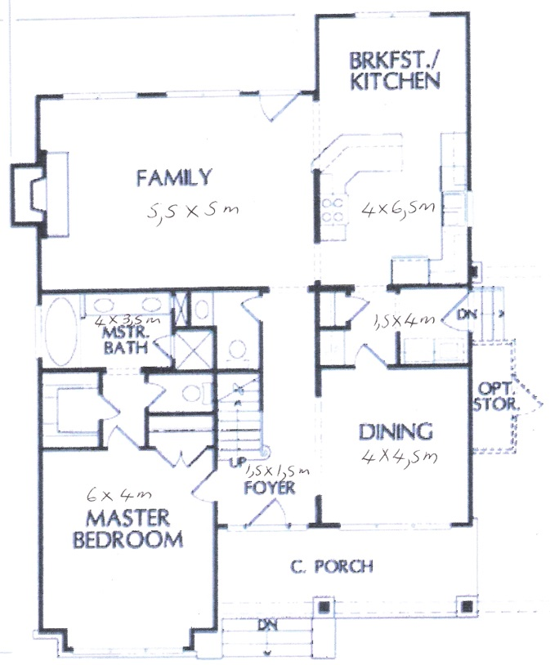  - Calculate the area of each of the rooms in the house:  - At R48.50 a square metre, what is the cost of laying a cement floor in a garage that is 6m long and 4 m wide?
  Master bedroom
  Master bathroom
  Foyer
  Dining room
  Side entrance at kitchen
  Breakfast nook and kitchen
  Family room
  Entire house
  Master bedroom
  Master bathroom
  Foyer
  Dining room
  Side entrance at kitchen
  Breakfast nook and kitchen
  Family room
________________________________________________________________________________________________________________________________________________________________________________________________________________________________________________________________________________________________________________________________________________________________________________________________________________________________________________________________________________________________________________________________________________________________________________________________________________________________________________________________________________________________________________________________________________________________________________________________________________________________________________________________________________________________________________________________________________________________________________________________________________________________________________________________________________________________________________________________________________________________________________________________________________________________________________________________________________________________________________________________________________________________________________________________________________________________________________________________________________________________________________________________________________________________________________________________________________________________________________________________________________________________________________________________________________________________________________________________________________________________________________________________________________________________________________________________________________________________________________________________________________________________________________________________________________________________________________________________________________________________________________________________________________________________________________________________________________________________________________________________________________________________________________________
Activity 2 | Write down the formulae for calculating volume for each of the shapes shown in your Learner Guide:
  Shape | Formula
  Cylinder
  Rectangular solid
  Cube
  Pyramid
__________________________________________________________________________________________________________________________________________________________________________________________________________________________________________________________________________________________________________________________________________________________________________________________________________________________
Activity 3 | The rectangular swimming pool referred to in 1.2 is 11,5 m long, 5 m wide and 3m deep throughout. Calculate its volume.
__________________________________________________________________________________________________________________________________________________________________________________________________________________________________________________________________________________________________________________________________________________________________________________________________________________________________________________________________________________________________________________________________________________________________________________________________________________________________________________________________________________________________________________________________________________________________________________________________________________________________________________________________________________________________________________________________________________________________________________________________________________________________________________________________________________________________________
Activity 4 | Calculate the area of a triangle whose base is 13.9 m. and whose altitude is 7.8 m:
________________________________________________________________________________________________________________________________________________________________________________________________________________________________________________________________________________________________________________________________________________________________________________________________________________________________________________________________________________________________________________________________________________________________________________________________________________________________________________________________________________________________________________________________________________________________________________________________________________________________________________________________________________________________________________________________________________________________________________________________________________________________________________________________________________________________________________________________________________________________________________________________________________________________________________________________________________________________________________________________________________________________

Activity 5 | Calculate the area of parallelogram GDEF if the base is 5m and the altitude is 3,2m  F  E  3,2m  G  D  5m
____________________________________________________________________________________________________________________________________________________________________________________________________________________________________________________________________________________________________________________________________________________________________________________________________________________________________________________________________________________________________________________________________________________________________________________________________________________________________________________________________________________________________________________________________________________________________________________________________________________________________________________
Activity 6 | Calculate the area of a parallelogram whose base is 17,9 cm and whose altitude is 30,25 cm in length.
____________________________________________________________________________________________________________________________________________________________________________________________________________________________________________________________________________________________________________________________________________________________________________________________________________________________________________________________________________________________________________________________________________________________________________________________________________________________________________________________________________________________________________________________________________________________________________________________________________________________________________________
Activity 7 | Find the area of a rectangle whose base is 8.4 m and whose altitude is 15.6 m in length. Show your calculation:
______________________________________________________________________________________________________________________________________________________________________________________________________________________________________________________________________________________________________________________________________________________________________________________________________________________________________________________________________________________________________________________________________________________________________________________________________________________________________________________________________________________________________________________________________________________________________________________________________________________________________________________________________________________________________________________________________
Activity 8 | How many cubes were needed to build the design in this figure?  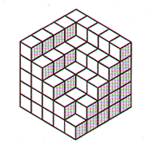
______________________________________________________________________________________________________________________________________________________________________________________________________________________________________________________________________________________________________________________________________________________________________________________________________________________________________________________________________________________________________________________________________________________________________________________________________________________________________________________________________________________________________________________________________________________________________________________________________________________________________________________________________________________________________________________________________
Activity 9 | Find the circumference and area of a circle whose diameter is 14 cm:
____________________________________________________________________________________________________________________________________________________________________________________________________________________________________________________________________________________________________________________________________________________________________________________________________________________________________________________________________________________________________________________________________________________________________________________________________________________________________________________________________________________________________________________________________________________________________________________________________________________________________________________
Activity 10 | Can a circular table top with diameter 2.7 metres long fit through a doorway 2.5 metres high and 1 metre wide? Why or why not?
____________________________________________________________________________________________________________________________________________________________________________________________________________________________________________________________________________________________________________________________________________________________________________________________________________________________________________________________________________________________________________________________________________________________________________________________________________________________________________________________________________________________________________________________________________________________________________________________________________________________________________________
Activity 11 | How far up on a wall of a building will a 10-meter ladder reach if the foot of the ladder is 1,25 metres from the wall? Draw the situation and then explain your answer.
__________________________________________________________________________________________________________________________________________________________________________________________________________________________________________________________________________________________________________________________________________________________________________________________________________________________________________________________________________________________________________________________________________________________________________________________________________________________________________________________________________________________________________________________________________________________________________________________________________________________________________________________________________________________________________________________________________________________________________________________________________________________________________________________________________________________________________
Activity 12 | What is the length of the longest pole you could put in a rectangular storage room 12 units long, 9 units wide, and 8 units high? Explain.
____________________________________________________________________________________________________________________________________________________________________________________________________________________________________________________________________________________________________________________________________________________________________________________________________________________________________________________________________________________________________________________________________________________________________________________________________________________________________________________________________________________________________________________________________________________________________________________________________________________________________________________
Activity 13 | Calculate the sum of the measures of the interior angles of the following polygons. Name the shape and then do your calculations next to the relevant shape:  
____________________________________________________________________________________________________________________________________________________________________________________________________________________________________________________________________________________________________________________________________________________________________________________________________________________________________________________________________________________________________________________________________________________________________________________________________________________________________________________________________________________________________________________________________________________________________________________________________________________________________________________
Activity 14 | Draw a picture of your file in the space provided. Measure your file and write its dimensions down on the drawing. Calculate what size paper you would need to cover it. Leave 2cm on each side for the overlap.
____________________________________________________________________________________________________________________________________________________________________________________________________________________________________________________________________________________________________________________________________________________________________________________________________________________________________________________________________________________________________________________________________________________________________________________________________________________________________________________________________________________________________________________________________________________________________________________________________________________________________________________________________________________________________________________________________________________________________________________________________________________________________________________________________________________________________________________________________________________________________________________________________________________________________________________________________________________________________________________________________________________________________________________________________________________________________________________________________________________________________________________________________________________________________________________________________________________________________________________________________________________________________________________________________________________________________________________________________________________________________________________________________________________________________________________________________________________________________________________________________________________________________________________________________________________________________________________________________________________________________________________________________________________
Activity 15 | The training room  - If you wanted to carpet the training room, what size carpet would you need to buy?  - If you wanted to tile the training room walls, and each box of tiles= 1,2m², how many boxes would you require?  - At a cost of R55 per box, how much would it cost to tile the training room?
________________________________________________________________________________________________________________________________________________________________________________________________________________________________________________________________________________________________________________________________________________________________________________________________________________________________________________________________________________________________________________________________________________________________________________________________________________________________________________________________________________________________________________________________________________________________________________________________________________________________________________________________________________________________________________________________________________________________________________________________________________________________________________________________________________________________________________________________________________________________________________________________________________________________________________________________________________________________________________________________________________________________________________________________________________________________________________________________________________________________________________________________________________________________________________________________________________________________________________________________________________________________________________________________________________________________________________________________________________________________________________________________________________________________________________________________________________________________________________________________________________________________________________________________________________________________________________________________________________________________________________________________________________________________________________________________________________________________________________________________________________________________________________________
Activity 16 | You want to share the following recipe with your friends in Australia and Britain. Convert the recipe to their relevant units:  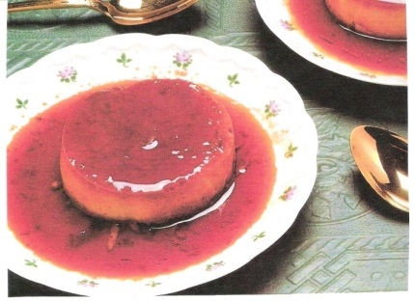  Classic Crème Caramel  940 ml milk  375 ml vanilla sugar  5 eggs  4 egg yolks  15 ml vanilla  Scald the milk and allow to cool 20 minutes. In a saucepan, melt 180 ml of sugar and cook until dark brown, stirring constantly. Take care not to scorch. Pour into a warm mould, covering the bottom and sides. Beat the eggs and egg yolks with the remaining sugar. Slowly whip in the milk and vanilla. Pour into the sugar-lined mould.  Place mould in a second pan filled halfway with hot water. Bake for 45 minutes in a 160° oven. Cool, then chill. To serve, invert on to a rimmed serving platter.  SERVES 6
   | Britain (Imperial) | Australia
  Milk (940 ml)
  Vanilla sugar (375 ml)
  Vanilla (15 ml)
  Oven (160°)
____________________________________________________________________________________________________________________________________________________________________________________________________________________________________________________________________________________________________________________________________________________________________________________________________________________________________________________________________________________________________________________________________________________________________________________________________________________________________________________________________________________________________________________________________________________________________________________________________________________________________________________
Activity 17 | Speed and distance  Read the 2004 Audi A6 specifications (you will recognise them from unit standard 119457) and then answer the questions that follow:  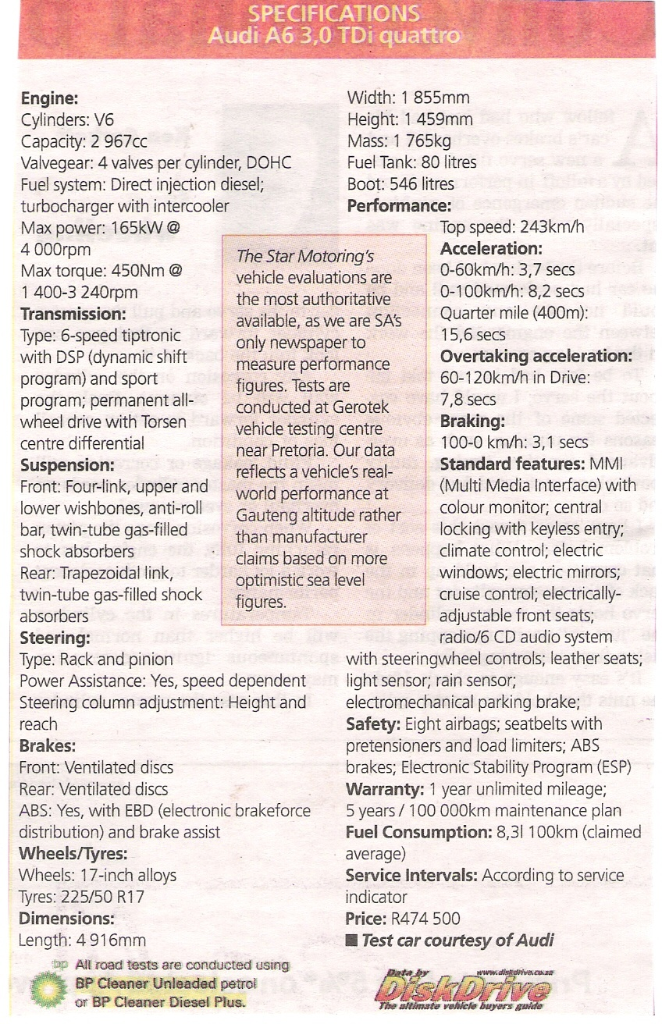  - Find three examples of specifications regarding volume:  - If the diameter of the Audi’s wheels is 17 inches, calculate the circumference of the wheel.  - If you travel to Durban from Johannesburg (650 km) in your new Audi A6, how much petrol will you use on average?  - How long will it take you to get to Durban from Johannesburg at an average speed of 120 km/h?  - Give the dimensions of the Audi A6 in metres:
______________________________________________________________________________________________________________________________________________________________________________________________________________________________________________________________________________________________________________________________________________________________________________________________________________________________________________________________________________________________________________________________________________________________________________________________________________________________________________________________________________________________________________________________________________________________________________________________________________________________________________________________________________________________________________________________________________________________________________________________________________________________________________________________________________________________________________________________________________________________________________________________________________________________________________________________________________
Activity 18 | The following chart reflects the profits (in millions) made by three shafts of a platinum mine over a period of a year.  Compare the performance of the three shafts by reading the figures at the end of each quarter off the chart. Tabulate the figures. Write in the names of the shafts on the left. (The answers will be approximations)
  Shaft | 1st | 2nd | 3rd | 4th
____________________________________________________________________________________________________________________________________________________________________________________________________________________________________________________________________________________________________________________________________________________________________________________________________________________________________________________________________________________________________________

Assessment Feedback Report

Facilitator Feedback
&
Remarks
Facilitator Feedback  &  Remarks | Competent (Tick Relevant) |  |  |  | Not Yet Competent(Tick Relevant)
Learner Feedback
& Comments
Facilitator Declaration | I……………………………………………......................... (Facilitator) hereby certify that I have examined the learner workbook and I am satisfied with the evidence provided by the learner.
Learner Declaration | I……………………………………………………………………. (Learner) declare that I am satisfied that the feedback given to me by the Facilitator was relevant, sufficient and done in a constructive manner. I accept the assessment judgment and have no further questions relating to this particular assessment event.
Learner Signature |  | Date |  | Facilitator Signature |  | Date
Assessor Declaration | I……………………………………………............. (Assessor) hereby certify that I have examined the learner workbook and [I am] [I am not] (circle relevant) satisfied with the Facilitator Judgment of this assessment.
Assessor Signature |  | Date |  | Moderator Signature |  | Date

Learning Unit 3 | US: 7468, NQF Level 4 Worth 6 Credits  Use mathematics to investigate and monitor the financial aspects of personal, business, national and international issues
Unit Standard Purpose | This unit standard will be useful to people who aim to achieve recognition at some level in Further Education and Training or to meet the Fundamental requirement of a wide range of qualifications registered on the National Qualifications Framework.  People credited with this unit standard are able to:  - Use mathematics to plan and control financial instruments including insurance and assurance, unit trusts, stock exchange dealings, options, futures and bonds  - Use simple and compound interest to make sense of and define a variety of situations including mortgage loans, hire purchase, present values, annuities and sinking funds  - Investigate various aspects of costs and revenue including marginal costs, marginal revenue and optimisation of profit  - Use mathematics to debate aspects of the national and global economy, including tax, productivity and the equitable distribution of resources.
Learning Assumed to be in Place | The credit value is based on the assumption that people starting to learn towards this unit standard are competent in Mathematical Literacy and Communications at NQF level 3

Warning:
We are aware of the sensitive nature of this information. You can give fictitious figures, but if you want this course to really make a difference, you will not deviate by more than 10% of actual.

Activity 1 | Calculate your liabilities
  I owe:
  House | R
  Car | R
  Clothes | R
  Water & lights (arrears) | R
  Hire purchase | R
  Cash loans | R
  Work loan | R
  Other loans | R
  TOTAL | R
____________________________________________________________________________________________________________________________________________________________________________________________________________________________________________________________________________________________________________________________________________________________________________________________________________________________________________________________________________________________________________________________________________________________________________________________________________________________________________________________________________________________________________________________________________________________________________________________________________________________________________________
Activity 2 | Calculate your assets
  I own: | Estimated value
  House | R
  Car | R
  Household content (incl. Furniture, clothes, etc.) | R
  Policies (investments) | R
  Other: | R
  Other: | R
  TOTAL | R
__________________________________________________________________________________________________________________________________________________________________________________________________________________________________________________________________________________________________________________________________________________________________________________________________________________________________________________________________________________________________________________________________________________________________________________________________________________________________________________________________________________________________________________________________________________________________
Activity 3 | Assets –liabilities = _________________________  Therefore, I have a positive/ negative net worth (delete the word that is not applicable)
______________________________________________________________________________________________________________________________________________________________________________________________________________________________________________________________________________________________________________________________________________________________________________________________________________________________________________________________________________________________________________________________________________________________________________________________
Activity 4 | Write down monthly expenses (5 of each):  Use the following budget sheet:
  Expenses | Estimated | Actual
  Fixed essential expenses
  Sub-total | R | R
  Changing (variable) expenses | Estimated | Actual
  Sub-total | R | R
  Discretionary (luxury) expenses | Estimated | Actual
  Sub-total | R | R
  TOTAL | R | R
________________________________________________________________________________________________________________________________________________________________________________________________________________________________________________________________________________________________________________________________________________________________________________________________________________________________________________________________________________________________________________________________________________________________________________________________________________________________________________________________________________________________________________________________________________________________________________________________________________________________________________________________________________________________________________________________________________________________________________________________________________________
Activity 5 | Identify the areas where your actual expenses are different from your estimated expenses.
__________________________________________________________________________________________________________________________________________________________________________________________________________________________________________________________________________________________________________________________________________________________________________________________________________________________________________________________________________________________________________________________________________________________________________________________________________________________________________________________________________________________________________________________________________________________________________________________________________________________________________________________________________________________________________________________________________________________________________________________________________________________________________________________________________________________________________
Activity 6 | Explain the reasons for the variances in your estimated and actual spending
____________________________________________________________________________________________________________________________________________________________________________________________________________________________________________________________________________________________________________________________________________________________________________________________________________________________________________________________________________________________________________________________________________________________________________________________________________________________________________________________________________________________________________________________________________________________________________________________________________________________________________________
Activity 7 | Calculate what percentage your discretionary (luxury) expenses are of total expenditure:
______________________________________________________________________________________________________________________________________________________________________________________________________________________________________________________________________________________________________________________________________________________________________________________________________________________________________________________________________________________________________________________________________________________________________________________________________________________________________________________________________________________________________________________________________________________________________________________________________________________________________________________________________________________________________________________________________
Activity 8 | Ways in which I plan to reduce expenditure (Name 5)
________________________________________________________________________________________________________________________________________________________________________________________________________________________________________________________________________________________________________________________________________________________________________________________________________________________________________________________________________________________________________________________________________________________________________________________________________________________________________________________________________________
Activity 9 | - Using the formula for calculating simple interest (I= Prt), calculate how much interest you will earn after 1 year if you save R150 per month at 8% per annum. Show your calculations.  - How much will you have in your savings account after 5 years if you continue to save R150 per month and continue to earn 8% interest p.a.? Use the formula for calculating compound interest A = P (1 + r) ⁿ. The interest is added once a year.
________________________________________________________________________________________________________________________________________________________________________________________________________________________________________________________________________________________________________________________________________________________________________________________________________________________________________________________________________________________________________________________________________________________________________________________________________________________________________________________________________________________________________________________________________________________________________________________________________________________________________________________________________________________________________________________________________________________________________________________________________________________________________________________________________________________________________________________________________________________________________________________________________________________________________________________________________________________________________________________________________________________________
Activity 10 | Purchasing a vehicle  You’ve seen the following price list and have decided to purchase the Supervan  - Subject to Bank approval. Terms and conditions apply. All prices include VAT.  - Calculate the total cost of the vehicle for each of the four finance options.  - Calculate the interest paid in Rands on each of the four options.  - Calculate the interest percentage for all four options.  (Do your calculations on a separate page from the Workbook and enter the answers in the table on the next page.)  - Choose a finance option and say why you have chosen that particular option:  - I choose Option , because  - Your home loan is one of your most dramatic examples of the effect of compound interest over time. How much do you pay in total over 20 years for your R450 000 home if your monthly repayment stays at R4 500?  - If you were to increase your monthly repayment by 25%, you would pay your bond off in 125 months. Calculate what you would pay (and save) in total:
  VEHICLE | RETAIL | Instalment sale.  54 months.  10% deposit | Straight lease  60 months | Lease (60 months). No deposit. 30% residual | Lease (60 months). 60 000 km maintenance plan. No deposit. No residual
  Extravan | R60270 | R1299pm | R1359pm | R1167pm | R1469pm
  Supervan | R105400 | R2249pm | R2329pm | R1989pm | R2449pm
  Luxavan | R130710 | R2789pm | R2889pm | R2465pm | R2999pm
  Incredivan | R186300 | R3939pm | R4089pm | R3485pm | R4239pm
  Dreamvan | R193940 | R4119pm | R4269pm | R3635pm | R4399pm
  Option | Total paid | Retail price | Interest in R | Interest %
  1
  2
  3
  4
______________________________________________________________________________________________________________________________________________________________________________________________________________________________________________________________________________________________________________________________________________________________________________________________________________________________________________________________________________________________________________________________________________________________________________________________________________________________________________________________________________________________________________________________________________________________________________________________________________________________________________________________________________________________________________________________________________________________________________________________________________________________________________________________________________________________________________________________________________________________________________________________________________________________________________________________________________________________________________________________________________________________________________________________________________________________________________________________________________________________________________________________________________________________________________________________________________________________________________________________________________________________________________________________________________________________________________________________________________________________________________________________________________________________________________________________________________________________
Activity 11 | Depreciation of fixed assets  - You bought the Extravan for R70 000. Show the annual depreciation in the table below:  - Calculate what your Supervan is worth after 2 years
  Year | Depreciation
  1
  2
  3
  4
  Total
________________________________________________________________________________________________________________________________________________________________________________________________________________________________________________________________________________________________________________________________________________________________________________________________________________________________________________________________________________________________________________________________________________________________________________________________________________________________________________________________________________
Activity 12 | The effect of inflation on my pocket  - Work out what you will need to earn at age 65 to maintain your current standard of living if inflation stays at 6% per year:  - Multiply the amount in the last column with 12 to work out the annual salary you will need to be earning:  - How much should you be putting away for your retirement?  - Explain what we, as ordinary citizens, can do to bring down the inflation rate in South Africa.  - What can and does the South African government do to bring down the inflation rate?
  Age | Salary
  R X12 = R per annum
______________________________________________________________________________________________________________________________________________________________________________________________________________________________________________________________________________________________________________________________________________________________________________________________________________________________________________________________________________________________________________________________________________________________________________________________________________________________________________________________________________________________________________________________________________________________________________________________________________________________________________________________________________________________________________________________________________________________________________________________________________________________________________________________________________________________________________________________________________________________________________________________________________________________________________________________________________________________________________________________________________________________________________________________________________________________________________________________________________________________________________________________________________________________________________________________________________________
Activity 13 | Using the tax table in your Learner Guide, answer the following:  - How much tax is deducted from someone who is under 65 and earns  - R11 100 per month?  - Calculate the tax as a percentage of the above salary  - Marj earns R260 890 per year. Calculate how much tax has to be deducted every month by using the information in your Learner Guide
______________________________________________________________________________________________________________________________________________________________________________________________________________________________________________________________________________________________________________________________________________________________________________________________________________________________________________________________________________________________________________________________________________________________________________________________________________________________________________________________________________________________________________________________________________________________________________________________________________________________________________________________________________________________________________________________________
Activity 14 | Calculate the tax the following companies pay:  - Profit is R158 200 per year (show your calculations)  - Profit is R0.8 million per year (show your calculations)
______________________________________________________________________________________________________________________________________________________________________________________________________________________________________________________________________________________________________________________________________________________________________________________________________________________________________________________________________________________________________________________________________________________________________________________________________________________________________________________________________________________________________________________________________________________________________________________________________________________________________________________________________________________________________________________________________
Activity 15 | A team member welds 30 widgets per day. She works 8 hours per day.  - What is her input and what is her output?  - If the value added to each widget by the welding operation is estimated at R3 each, or a total of R90 and the welder is paid R4,50 an hour, what would the productivity of the welding operation be?  - Convert that ratio to percentage  - If your team’s productivity ratio was 2.3: 1 last year and now it is 2.1: 1 this year, what is the percentage decrease? (Show your calculation)
____________________________________________________________________________________________________________________________________________________________________________________________________________________________________________________________________________________________________________________________________________________________________________________________________________________________________________________________________________________________________________________________________________________________________________________________________________________________________________________________________________________________________________________________________________________________________________________________________________________________________________________________________________________________________________________________________________________________________________________________________________________________________________________________________________________________________________________________________________________________________________________________
Activity 16 | Tick the answers that apply to your current lifestyle:
  I… | Yes | No
  - Have recently moved to a more expensive home
  - Have bought a second property to rent out
  - Will still have a bond/bonds to settle when I retire
  - Buy top-of-the-range vehicles with my car allowance
  - Buy a new car every two years
  - Love to spoil my family and/ or friends with gifts
  - Buy myself nice things (I work hard and deserve a treat)
  - Am confident that my company pension/provident fund is adequate
  - Know that my spouse’s pension will be enough for us both
  - Have a defined savings plan
  - Have been putting money away each month since my first pay cheque
  - Have a financial planner
  - Have a financial plan
  - Have implemented my financial plan
  - Monitor and update my financial plan at least once a year
  - Have quantified my expected retirement expenses
  - Have made provision for possible medical expenses as I age
  - Am prepared to downscale my lifestyle before I retire
  Insights gained from the discussion:
  I am currently:
  I will have to:
________________________________________________________________________________________________________________________________________________________________________________________________________________________________________________________________________________________________________________________________________________________________________________________________________________________________________________________________________________________________________________________________________________________________________________________________________________________________________________________________________________
Activity 17 | Answer the questions based on the graph below:  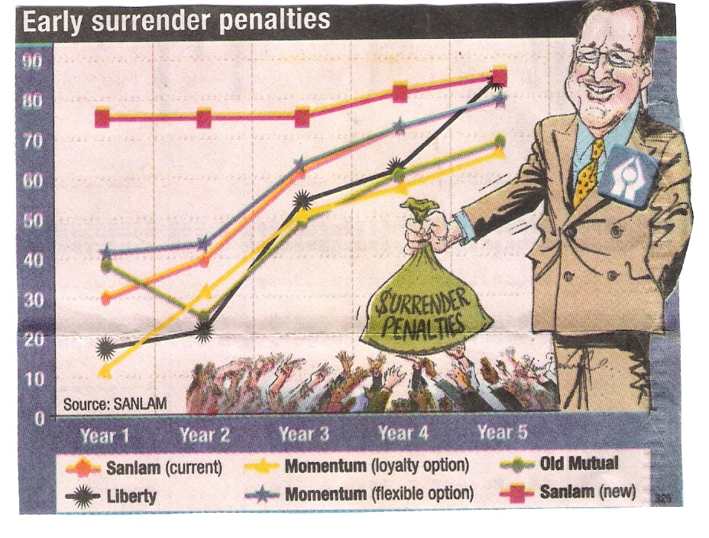  - Explain in which way Sanlam’s new penalty structure differs from its current structure  - Complete the following table in which you compare the early surrender penalties (in %) imposed by the following companies:
  Company | Year 3 | Year 5
  Old Mutual
  Liberty
  Momentum (flexible)
____________________________________________________________________________________________________________________________________________________________________________________________________________________________________________________________________________________________________________________________________________________________________________________________________________________________________________________________________________________________________________
Activity 18 | - You have invested R100 per month @ 10% per annum in an endowment policy with Liberty. After a period of two years you decide to surrender the policy. What is your expected payout?  - Your unit trust investment of R100 per month grows at 10% per annum. Annual costs of 5.25% are deducted. After 2 years you decide to sell the units. What is your investment worth?
__________________________________________________________________________________________________________________________________________________________________________________________________________________________________________________________________________________________________________________________________________________________________________________________________________________________________________________________________________________________________________________________________________________________________________________________________________________________________________________________________________________________________________________________________________________________________________________________________________________________________________________________________________________________________________________________________________________________________________________________________________________________________________________________________________________________________________
Activity 19 | - List TWO benefits of Retirement Annuities  - Sam is retiring in a year’s time and is trying to calculate the lump sum payout that he can receive from his RA. His average tax rate is 40% and the total investment is R850 000. How much will his lump sum payout be after tax?
____________________________________________________________________________________________________________________________________________________________________________________________________________________________________________________________________________________________________________________________________________________________________________________________________________________________________________________________________________________________________________________________________________________________________________________________________________________________________________________________________________________________________________________________________________________________________________________________________________________________________________________
Activity 20 | Compare life cover and funeral cover, stating the advantages and disadvantages of each:
  Funeral cover | Life cover
  Advantages: | Advantages:
  Disadvantages: | Disadvantages:
__________________________________________________________________________________________________________________________________________________________________________________________________________________________________________________________________________________________________________________________________________________________________________________________________________________________
Activity 21 | - You have realised that instead of reducing your car’s short-term insurance premium as its book value decreases, your insurer has actually increased the premium by 10% per year “to keep up with inflation”. If your premium started off at R450 per month, what have you paid in total after 2 years?  - Your premium should actually have decreased by 20% per annum. What is the total amount you should have paid in premiums over a two-year period?
____________________________________________________________________________________________________________________________________________________________________________________________________________________________________________________________________________________________________________________________________________________________________________________________________________________________________________________________________________________________________________________________________________________________________________________________________________________________________________________________________________________________________________________________________________________________________________________________________________________________________________________
Activity 22 | - Mary has 1278 units in a unit trust fund. She wants to calculate the value of her investment. When she looks at the shares page in the daily newspaper, she sees that the NAV = 465.20. What is her investment worth?  - What are the tax implications if Mary were to sell her units?
____________________________________________________________________________________________________________________________________________________________________________________________________________________________________________________________________________________________________________________________________________________________________________________________________________________________________________________________________________________________________________________________________________________________________________________________________________________________________________________________________________________________________________________________________________________________________________________________________________________________________________________
Activity 23 | Calculate the charges on a R35 000 share purchase:  Stockbroker’s basic charge R20  Brokerage fee (about 1,25% of value of transaction) ______________  Uncertified Securities Tax (0,25% on purchase) ______________  Insurance R0.19  Settlement fee (STRATE) R10.92  VAT _______________  TOTAL COSTS R_______________
____________________________________________________________________________________________________________________________________________________________________________________________________________________________________________________________________________________________________________________________________________________________________________________________________________________________________________________________________________________________________________________________________________________________________________________________________________________________________________________________________________________________________________________________________________________________________________________________________________________________________________________
Activity 24 | Study the results of the following research done by the CSIR:  Gated communities, especially enclosed neighbourhoods, are a frequently discussed issue in South Africa. Newspapers write about it, police talk about it, residents argue about it and many Local Authorities have to make decisions about it. Numerous questions are asked, regarding:  - the legal implications regarding the enclosure of public space;  - the privatisation of public functions such as road maintenance and its implications for taxes;  - the fragmentation of urban areas;  - the values of properties or houses within enclosed areas;  - the gain/loss of social connection and contact and increasing social exclusion and separation;  - the perception of safety versus actual reports of crime decreasing in gated communities; and  - the role of private security within enclosed areas  The initial research conducted by the CSIR revealed that, although enclosed neighbourhoods are predominantly encountered in Gauteng, smaller towns are increasingly facing requests for street enclosures. Out of 20 cities and towns that indicated that they have received requests for road closures, 60% were towns with less than 500 000 inhabitants such as Bethlehem and Port Shepstone. One of the substructures of Johannesburg has already had 212 applications for road closures by early 2000.  Statistics obtained from MBS Consulting Engineers show that not all the existing enclosures are legal and that there were approximately 360 existing enclosures in one particular substructure of the Greater Johannesburg Metropolitan Area in 2000. One of the contributing factors to the high occurrence of enclosed neighbourhoods in Gauteng may be the exceptionally high level of fear of crime. A victim survey conducted by the Institute for Security Studies (ISS)indicated that 65.2% of Johannesburg residents and 50% of residents in Pretoria feel unsafe in their homes at night compared to 42.5% in Cape Town and 41.4% in Durban.  Gated Communities are not only the responsibility of those residents who wish to enclose their areas or to live in secure complexes. Some types directly influence the Local Authorities and their traditional public functions. While several municipalities across the country are receiving requests for neighbourhood enclosures, few have policies in place to address this situation.  Meanwhile, the occurrence of gated communities is growing daily and several questions are asked, especially regarding the long-term impact of this type of development on the urban future. Yet, recent research (2002) has indicated that it is very much an issue of balancing short-term need (crime reduction) with long-term costs and impact (impact on urban integration, urban management, etc.). In this sense, it will be necessary to distinguish between different types of gated communities and different models, since their impact and implications may vary considerably.  Debate the issue of gated communities in the light of the article in your Learner Guide regarding sustainable development and the equitable distribution of resources. Write the main insights from the debate in the space below:
  Arguments for | Arguments against
_____________________________________________________________________________________________________________________________________________________________________________________________________________________________________________________________________________________________________________________________________________________________________________________________________________________________________________________________________________________________________________________________________________________________________________________________________________________________________________________________________________________________________________________________________________________________________________________________________________________________________________________________________________________________________________________________________________________________________________________________________________________________________________________________________________________________________________________________________________________________________________________________________________________________________________________________________________

Assessment Feedback Report

Facilitator Feedback
&
Remarks
Facilitator Feedback  &  Remarks | Competent (Tick Relevant) |  |  |  | Not Yet Competent(Tick Relevant)
Learner Feedback
& Comments
Facilitator Declaration | I……………………………………………......................... (Facilitator) hereby certify that I have examined the learner workbook and I am satisfied with the evidence provided by the learner.
Learner Declaration | I……………………………………………………………………. (Learner) declare that I am satisfied that the feedback given to me by the Facilitator was relevant, sufficient and done in a constructive manner. I accept the assessment judgment and have no further questions relating to this particular assessment event.
Learner Signature |  | Date |  | Facilitator Signature |  | Date
Assessor Declaration | I……………………………………………............. (Assessor) hereby certify that I have examined the learner workbook and [I am] [I am not] (circle relevant) satisfied with the Facilitator Judgment of this assessment.
Assessor Signature |  | Date |  | Moderator Signature |  | Date

