
Learner Guide

Module 2
Mathematical Literacy
US: 9015, 9016, 7468

Further Education and Training Certificate: Information Technology: Technical Support
Qual ID: 78964
NQF LEVEL 4, Worth 165 Credits

Learner Information:

Name & Surname:
ID Number
Tel/Cell
Email Address
Organisation:
Facilitator Name:

Copyright
All rights reserved. The copyright of this document, its previous editions and any annexures thereto, is protected and expressly reserved. No part of this document may be reproduced, stored in a retrievable system, or transmitted, in any form or by any means, electronic, mechanical, photocopying, recording or otherwise without the prior permission.

Learner Guide Introduction
About | The purpose of this Learner Guide is to provide learners with the necessary knowledge and it provides a comprehensive overview of the module: Mathematical Literacy, and forms part of a series of moduralised Learner Guides that have been developed for the qualification: Further Education and Training Certificate: Information Technology: Technical Support - Qual ID: 78964 NQF LEVEL 4, Worth 165 Credits.  This Learner Guide has been designed to improve the skills and knowledge of learners, and thus enabling them to effectively and efficiently complete specific tasks.
Outcomes | At the end of this module, you will be able to:  - Apply knowledge of statistics and probability to critically interrogate and effectively communicate findings on life related problems  - Represent analyse and calculate shape and motion in 2-and 3-dimensional space in different contexts  - Use mathematics to investigate and monitor the financial aspects of personal, business, national and international issues
Assessment | The only way to establish whether a learner is competent and has accomplished the Learning Outcomes is through an assessment process.  Assessment involves collecting and interpreting evidence about the learner’s ability to perform a task.  This guide may include assessments in the form of activities, assignments, tasks or projects, as well as workplace practical tasks. Learners are required to perform tasks on the job to collect enough and appropriate evidence for their portfolio of evidence, proof signed by their supervisor that the tasks were performed successfully.
Qualify | To qualify and receive credits towards the learning program, a registered assessor will conduct an evaluation and assessment of the learner’s portfolio of evidence and competency
Learner Responsibility | Learners are required to attend the training workshops as a group or as specified by their organization. These workshops are presented in modules, and conducted by a qualified facilitator. The responsibility of learning rest with the learner, so:  - Be proactive and ask questions,  - Seek assistance and help from your facilitators, if required.

Learning Unit 1 | US: 9015, NQF Level 4 Worth 6 Credits  Apply knowledge of statistics and probability to critically interrogate and effectively communicate findings on life related problems
Unit Standard Purpose | This Unit Standard is designed to provide credits towards the mathematical literacy requirement of the NQF at Level 4. The essential purposes of the mathematical literacy requirement are that, as the learner progresses with confidence through the levels, the learner will grow in:  - A confident, insightful use of mathematics in the management of the needs of everyday living to become a self-managing person  - An understanding of mathematical applications that provides insight into the learner`s present and future occupational experiences `and so develop into a contributing worker  - The ability to voice a critical sensitivity to the role of mathematics in a democratic society and so become a participating citizen.  People credited with this unit standard are able to:  - Critique and use techniques for collecting, organising and representing data.  - Use theoretical and experimental probability to develop models, make predictions and study problems.  - Critically interrogate and use probability and statistical models in problem solving and decision making in real-world situations.
Learning Assumed to be in Place | The credit value is based on the assumption that people starting to learn towards this unit standard al-e competent in Mathematical Literacy and Communications at NQF level 3.

Session 1  SO 1 | Critique and use techniques for collecting, organising and representing data.
Learning Outcomes  (Assessment Criteria) | - Situations or issues that can be dealt with through statistical methods are identified correctly.  - Appropriate methods for collecting, recording and organising (data are used so as to maximise efficiency and ensure the resolution of a problem or issue  - Data sources and databases are selected in a manner that ensures the representativeness of the sample and the validity of resolutions.  - Activities that could result in contamination of data are identified and explanations are provided of the effects of contaminated data.  - Data is gathered using methods appropriate to the data type and purpose for gathering the data.  - Data collection methods are used correctly.  - Calculations and the use of statistics are correct.  - Graphical representations and numerical summaries are consistent with the data, are clear and appropriate to the situation and target audience.  - Resolutions for the situation or issue are supported by the data and are validated in terms of the context

Interpreting and analyzing data are problem-solving processes that are essential for dealing with information presented in many different forms, including but not limited to graphs and tables. Visual displays of data are found in reports and in the media, often being used to make decisions or to determine whether to support or reject arguments.
A Problem-Solving Process
The word statistics may bring to mind polls and surveys, or facts and figures in a newspaper article. But statistics is more than just a bunch of numbers: Statistics is a problem-solving process that seeks answers to questions through data.
By asking and answering statistical questions, we can learn more about the world around us. Statistics is used every day to help us gain insight into questions that affect our lives: Is our population growing or shrinking? What is the safest way to invest money? Will eating more fruits and vegetables really make us live longer?
What do you think of when you hear the word statistics?
Four things make a problem statistical: the way in which you ask the question, the role and nature of the data, the particular ways in which you examine the data, and the types of interpretations you make from the investigation. A statistics problem typically contains four components:
Asking a question gets the process started. It's important to ask a question carefully, with an understanding of the data you will use to find your answer. The question is most frequently derived from a problem situation and therefore can be seen as the core focus for the modelling of the data.
Collecting data to help answer the question is an important step in the process. You obtain data by measuring something, gathering relevant information pertaining to the problem situation or even through sampling which is another way to collect data. Experimentation is another.
Data must be organized, summarized, and represented properly in order to provide good answers to statistical questions. Also, the data you collect usually vary (i.e., they are not all the same), and you will need to account for the sources of this variation. The integrity of the source is of utmost importance to ensure for a accurate analysis.
After you analyze your data, you must interpret it in order to provide an answer -- or answers -- to the original question or problem situation.
You will become increasingly familiar with this process as you investigate different statistical problems.
From the recognition of trends to extracting patterns and extrapolating from data are higher-order problem-solving components of data interpretation and analysis. Therefore, before we can start to analyse data we need to understand how to collect the information, organise it effectively and then present it in an easy to understand format.

There are many forms of models which could be used to present and display information for analysis. Selecting the correct one could be critical so as to ensure that the applicable information can be analysed effectively.
Let’s have a look at a few of these examples. As you go through the examples with your facilitator, discuss other possible applications for the use of the models.
Line Graphs
A line graph is a way to summarize how two pieces of information are related and how they vary depending on one another. The numbers along a side of the line graph are called the scale.
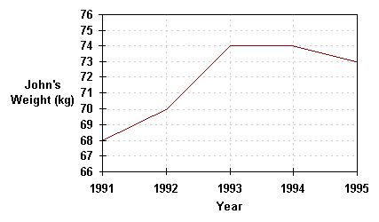
Example 1:
Description: The graph above shows how John's weight varied from the beginning of 1991 to the beginning of 1995. The weight scale runs vertically, while the time scale is on the horizontal axis. Following the gridlines up from the beginning of the years, we see that John's weight was 68 kg in 1991, 70 kg in 1992, 74 kg in 1993, 74 kg in 1994, and 73 kg in 1995. Examining the graph also tells us that John's weight increased during 1991 and 1995, stayed the same during 1991, and fell during 1994.
Use:

Pie Charts
A pie chart is a circle graph divided into pieces, each displaying the size of some related piece of information. Pie charts are used to display the sizes of parts that make up some whole.
Example 1:
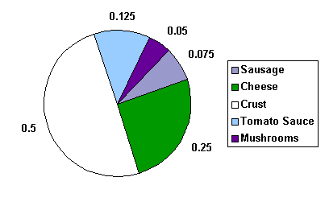
The pie chart below shows the ingredients used to make a sausage and mushroom pizza. The fraction of each ingredient by weight is shown in the pie chart below. We see that half of the pizza's weight comes from the crust. Note that the sum of the decimal sizes of each slice is equal to 1 (the "whole" pizza").

Example 2:
The pie chart below shows the ingredients used to make a sausage and mushroom pizza weighing 1.6 kg. This is the same chart as above, except that the labels no longer tell the fraction of the pizza made up by that ingredient, but the actual weight in kg of the ingredient used. To get the fraction of the pizza made up by any ingredient, divide the weight of the ingredient by the weight of the pizza. What fraction of the pizza does the sausage make up? We divide 0.12 kg by 1.6 kg, to get 0.075. This is the same value as in the pie chart in the previous example.

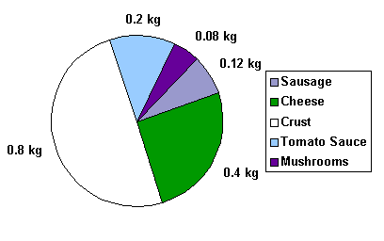
Example 3:
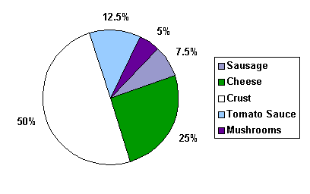
The pie chart below shows the ingredients used to make a sausage and mushroom pizza. The fraction of each ingredient by weight shown in the pie chart below is now given as a percent. Again, we see that half of the pizza's weight, 50%, comes from the crust. Note that the sum of the percent sizes of each slice is equal to 100%. Graphically, the same information is given, but the data labels are different. Always be aware of how any chart or graph is labelled.
Use:

Bar Graphs
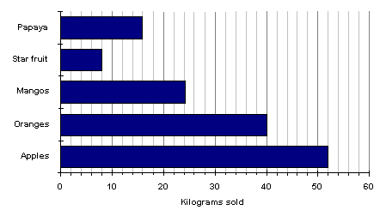
Bar graphs consist of an axis and a series of labelled horizontal or vertical bars that show different values for each bar. The numbers along a side of the bar graph are called the scale.
Example 1:
The bar chart below shows the weight in kilograms of some fruit sold one day by a local market. We can see that 52 kg of apples were sold, 40 kg of oranges were sold, and 8 kg of star fruit were sold.

Example 2:
A double bar graph is similar to a regular bar graph, but gives 2 pieces of information for each item on the vertical axis, rather than just 1. The bar chart below shows the weight in kilograms of some fruit sold on two different days by a local market. This lets us compare the sales of each fruit over a 2 day period, not just the sales of one fruit compared to another. We can see that the sales of star fruit and apples stayed most nearly the same. The sales of oranges increased from day 1 to day 2 by 10 kilograms. The same amount of apples and oranges was sold on the second day.
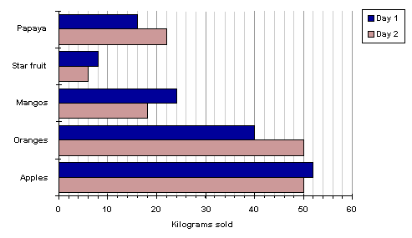
Uses:

Session 2  SO 2 | Use theoretical and experimental probability to develop models.
Learning Outcomes  (Assessment Criteria) | - Experiments and simulations are chosen and/or designed appropriately in terms of the situation to be modelled.  - Predictions are based on validated experimental or theoretical probabilities.  - The results of experiments and simulations are interpreted correctly in terms of the real context.  - The outcomes of experiments and simulations are communicated clearly.

PLANNING - WORKSHEET
In your groups, think of a general statistical question that could be answered through analysis. Now think carefully about the four steps listed on page 36. Answer the questions below to prepare for your strategic analysis of data to solve the problem or statistical question.
Question 1 – Step 1 (Select a Problem situation for data collection, organising & analysis)
What is the problem situation or statistical question? Write a brief description below.

Question 2 – Step 2 (Identify required data and relevant sources for analysis and presentation)
What data needs to be collected for analysis and presentation in your model? Also list the sources of your data.
Question 3 – Step 3 (Model, present and analyse data)
Which format will you use to model your data to present it accurately for analysis? How will you analyse the data? Write a brief description below.

Question 4 – Step 4 (Interpret results or solutions derived from analysis of data)
How will you interpret the results from the analysis? How will this provide a solution to the problem or answer the statistical question? Write a brief description below.


PROJECT 1
You will now need to complete your own analysis of a problem situation or statistical question. You may select any one of the following two topics:
- CRIME
- HEALTH
Take note of the following guidelines when completing your project:
- Follow the four steps listed on page 36 to guide you through your project.
- You will need to collect data from reliable sources of information to present in your model.
- Make use of your planning steps identified in the previous activity on pages 40-41.
You may also choose to complete your project on a separate sheet of paper and attach it to your Portfolio of Evidence. Alternatively, you can present your data and analysis in the space provided.

Probability Models – Demonstration
Read through the following with your facilitator.
- Make notes of the demonstration provided by your facilitator on the information provided below.
- Ask questions where required.
Introduction
A probability model is a mathematical representation of a random phenomenon. It is defined by its sample space, events within the sample space, and probabilities associated with each event.
The sample space S for a probability model is the set of all possible outcomes.
For example, suppose there are 5 marbles in a bowl. One is red, one is blue, one is yellow, one is green, and one is purple. If one marble is to be picked at random from the bowl, the sample space possible outcomes S = {red, blue, yellow, green, purple}. If 3 of the marbles are red and 2 are blue, then the sample space S = {red, blue}, since only two possible colour outcomes be possible. If, instead, two marbles are picked from a bowl with 3 red marbles and 2 blue marbles, then the sample space S = {(2 red), (2 blue), (1 red and 1 blue)}, the set of all possible outcomes.
An event A is a subset of the sample space S.
Suppose there are 3 red marbles and 2 blue marbles in a bowl. If an individual picks three marbles, one at a time, from the bowl, the event "pick 2 red marbles" can be achieved in 3 ways, so the set of outcomes A = {(red, red, blue),(red, blue, red), (blue, red, red)}. The sample space for picking three marbles, one at a time, is all of the possible ordered combinations of three marbles, S = {(red, red, red), (red, red, blue), (red, blue, red), (blue, red, red), (blue, blue, red), (blue, red, blue), (red, blue, blue)}. Since there are only 2 blue marbles, it is impossible to achieve the event {blue, blue, blue}.
A probability is a numerical value assigned to a given event A. The probability of an event is written P(A), and describes the long-run relative frequency of the event. The first two basic rules of probability are the following:
Rule 1: Any probability P(A) is a number between 0 and 1 (0 < P(A) < 1).
Rule 2: The probability of the sample space S is equal to 1 (P(S) = 1).
Suppose five marbles, each of a different colour, are placed in a bowl. The sample space for choosing one marble, from above, is S = {red, blue, yellow, green, purple}. Since one of these must be selected, the probability of choosing any marble is equal to the probability of the sample space S = 1. Suppose the event of interest is choosing the purple marble, A = {purple}. If it is equally likely that any one marble will be selected, then the probability of choosing the purple marble, P (A) = 1/5. In general, the following formula describes the calculation of probabilities for equally likely outcomes:
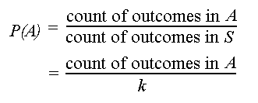
If there are k possible outcomes for a phenomenon and each is equally likely, then each individual outcome has probability 1/k.
The probability of any event A is

Session 3  SO 3 | Critically interrogate and use probability and statistical models.
Learning Outcomes  (Assessment Criteria) | - Statistics generated from the data are interpreted meaningfully and interpretations are justified or critiqued.  - Assumptions made in the collection or generation of data and statistics are defined or critiqued appropriately.  - Tables, diagrams, charts and graphs are used or critiqued appropriately in the analysis and representation of data, statistics and probability values  - Predictions, conclusions and judgements are made on the basis of valid arguments and supporting data, statistics and probability models.  - Evaluations of the statistics identify potential sources of bias, errors in measurement, potential uses and misuses and their effects.

Read the following presentation of information carefully then answer the questions to follow to create your own analysis of the data presented in this study.
South Africa's population
South Africa is a nation of over 47-million people of diverse origins, cultures, languages and beliefs.
According to the mid-2006 estimates from Statistics South Africa, the country's population stands at some 47.4-million, up from the census 2001 count of 44.8-million.
Africans are in the majority at 37.7-million, making up 79.5% of the total population. The white population is estimated at 4.4-million (9.2%), the coloured population at 4.2-million (8.9%) and the Indian/Asian population at 1.2-million (2.5%).
South Africa's population by race
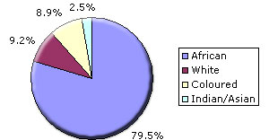
While more than three-quarters of South Africa's population is black African, this category is neither culturally nor linguistically homogenous. Nine of the country's 11 official languages are African, reflecting a variety of ethnic groupings which nonetheless have a great deal in common in terms of background, culture and descent.
South Africa's population by language
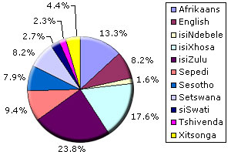

Conclusion
Africans include the Nguni people, comprising the Zulu, Xhosa, Ndebele and Swazi; the Sotho-Tswana people, comprising the Southern, Northern and Western Sotho (Tswana); the Tsonga; and the Venda.
South Africa's white population descends largely from the colonial immigrants of the late 17th, 18th and 19th centuries - Dutch, German, French Huguenot and British. Linguistically it is divided into Afrikaans- and English-speaking groups, although many small communities that have immigrated over the last century retain the use of other languages.
The label "coloured" is a contentious one, but still used for people of mixed race descended from slaves brought in from East and central Africa, the indigenous Khoisan who lived in the Cape at the time, indigenous Africans and whites. The majority speak Afrikaans.
Khoisan is a term used to describe two separate groups, physically similar in being light-skinned and small in stature. The Khoi, who were called Hottentots by the Europeans, were pastoralists and were effectively annihilated; the San, called Bushmen by the Europeans, were hunter-gatherers. A small San population still lives in South Africa.
The majority of South Africa's Asian population is Indian in origin, many of them descended from indentured workers brought to work on the sugar plantations of the eastern coastal area then known as Natal in the 19th century. They are largely English-speaking, although many also retain the languages of their origins. There is also a significant group of Chinese South Africans.
In terms of religious affiliation, about two-thirds of South Africans are Christian, mainly Protestant. They belong to a variety of churches, including many that combine Christian and traditional African beliefs. Many non-Christians espouse these traditional beliefs. Other significant religions are Islam, Hinduism and Judaism.
WORKSHEET - Answer the following questions:
- Describe the possible statistical questions which were addressed in the above analysis.

- Describe the type of data which was used in the presentation.

- What format was used to organise and present the information? What the format appropriate?

- Were you able to interpret the results of the analysis done?

Learning Unit 2 | US: 9016, NQF Level 4 Worth 4 Credits  Represent analyse and calculate shape and motion in 2-and 3-dimensional space in different contexts
Unit Standard Purpose | This unit standard is designed to provide credits towards the mathematical literacy requirements of the NQF at level 4. The essential purposes of the mathematical literacy requirements are that, as the learner progresses with confidence through the levels, the learner will grow in:  - An insightful use of mathematics in the management of the needs of everyday living to become a self-managing person.  - An understanding of mathematical applications that provides insight into the learner`s present and future occupational experiences and so develop into a contributing worker.  - The ability to voice a critical sensitivity to the role of mathematics in a democratic society and so become a participating citizen.  People credited with this unit standard are able to:  - Measure, estimate, and calculate physical quantities in practical situations relevant to the adult with increasing responsibilities in life or the workplace  - Explore analyse and critique, describe and represent, interpret and justify geometrical relationships and conjectures to solve problems in two and three dimensional geometrical situations
Learning Assumed to be in Place | The credit value is based on the assumption that people starting to learn towards this unit standard are competent in Mathematical Literacy and Communications at NQF level 3

Session 1  SO 1 | Measure, estimate, and calculate physical quantities in practical situations relevant to the adult
Learning Outcomes  (Assessment Criteria) | - Scales on the measuring instruments are read correctly.  - Quantities are estimated to a tolerance justified in the context of the need  - The appropriate instrument is chosen to measure a particular quantity.  - Quantities are measured correctly to within the least step of the instrument.  - Appropriate formulae are selected and used.  - Calculations are carried out correctly and the least steps of instruments used are taken into account when reporting final values.  - Symbols and units are used in accordance with SI conventions and as appropriate to the situation.

Measurements for most are a big part of our daily lives. Along every step of the way we are able to notice things which require measurement of some sort. Let’s have a look how measurement affects us:
Measurements can be found in just about everything. Let’s see if you can identify what type of measurement is used and / or required in the following situations:
- When you buy groceries and need to work out whether you have sufficient funds.
Measurement:

- When you calculate how much ingredients you will need to prepare the meal.
Measurement:

- When you work out how much overtime you have worked for a particular month.
Measurement:
- When you work out how much discount you are able to offer your client.
Measurement:

- When you determine the correct setting on the oven during baking.
Measurement:

- When you calculate how far it is that you will need to travel.
Measurement:

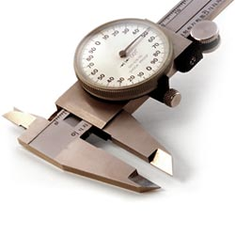
ACTIVITY - BRAINSTORM
Brainstorm in your groups what other forms of measurements are found in both your everyday work situations and personal lives. List your responses below:
EVERYDAY WORK SITUATIONS | EVERYDAY PERSONAL LIVES

Can you identify what measurements are measured with the following instruments and also indicate in what quantities each instrument would measure? Write your answers next to each picture below:
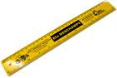
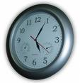
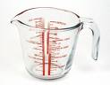

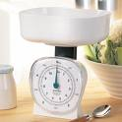
Making use of formulae to calculate measurements
The use of formulae’s to calculate measurements allow us to complete the calculation quicker and easier. The formulae provide us with set rules which we could follow to ensure that our calculation remains accurate and correct.
Let’s have a look at a simple example to help us understand this concept.
Finding Hours and Minutes
Formulae Purpose: How to find hours and minutes when the number of minutes is known.
Formulae:
- Divide the number of minutes by 60.
- The quotient is the number of hours.
- The remainder is the number of minutes greater than those in full hours.
Example:
If you have 240 free talk-time minutes on your cellular contract every month, you can use the above formulae are as follows:
- 240 minutes divide by 60 equals: 4 hours

Conclusion: You have 4 hours of free talk-time minutes every month to make use of.
Activity – examples of other formulae’s
Now give another two examples of formulae’s that you can make use of. Give examples to explain your answers. Record them below:
Formulae Purpose:

Formulae:

Example:

Formulae Purpose:

Formulae:

Example:

Session 2  SO 2 | Explore, analyse & critique, describe & represent, interpret and justify geometrical relationships
Learning Outcomes  (Assessment Criteria) | - Descriptions are based on a systematic analysis of the shapes and reflect the properties of the shapes accurately, clearly and completely.  - Descriptions include quantitative information appropriate to the situation and need.  - 3-dimensional objects are represented by top, front and side views.  - Different views are correctly assimilated to describe 3-dimensional objects.  - Available and appropriate technology is used in producing and analysing representations.  - Relations of distance and positions between objects are analysed from different views.  - Conjectures as appropriate to the situation, are based on well-planned investigations of geometrical properties.  - Representations of the problems are consistent with and appropriate to the problem context. The problems are represented comprehensively and in mathematical terms.  - Results are achieved through efficient and correct analysis and manipulation of representations.  - Problem-solving methods are presented clearly, logically and in mathematical terms.  - Reflections on the chosen problem solving strategy reveal strengths and weaknesses of the strategy.  - Alternative strategies to obtain the solution are identified and compared in terms of appropriateness and effectiveness.

Using and Analysing Shape and geometrical relationships
The ability of analysing and understanding shapes and figures allows us to make calculated decisions about everyday life when faced with certain situations. Shapes and figures have geometrical relationships which act as “formulae” and solutions to complex problems. Shapes might have equal sides, which mean that the measurement of those two equal sides will be the same.
Remember:
- Shape can take the form of distance over land and curves on a soccer ball. It is not always just considered as a particular figure of an object.
Now let’s have a look at a practical example
Problem situation:
If you travel from point A to point B and the distance from one point to the other is 5 km. What will the total distance be which needs to be travelled if one needs to go there and come back 5 times a day over 2 weeks?
Notes:
- The distance from point A to point B is 5km. The return distance will also be 5km, therefore totalling 10km.
- If the above distance of 10km per travel needs to be completed 5 times a day it would equal 50km a day.
- 50km a day worth of travelling over two weeks (14 days) will equal:
Total Distance: 700 km
Have a look at the picture below and answer the questions that follow by circling the correct answer/s:
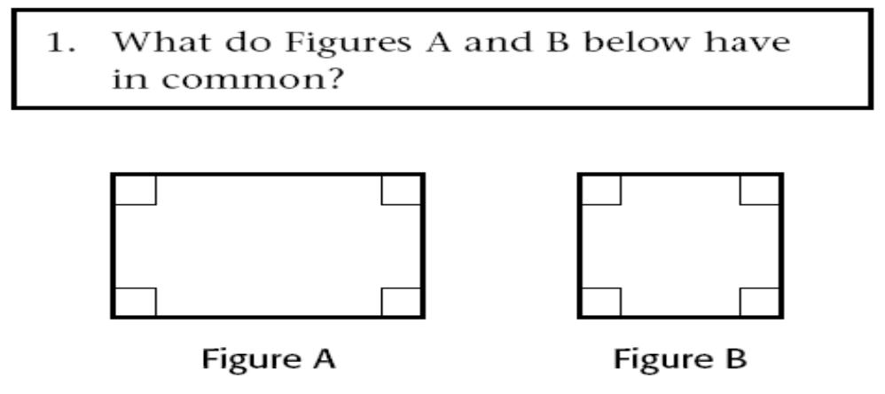

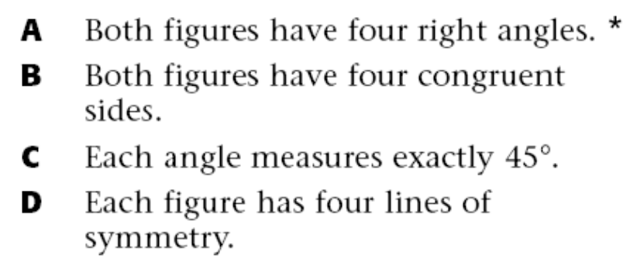

Question:
- In your own words, explain what the geometrical relationship is between the two shapes above.

Now let’s have a look at a practical example
Problem situation:
If you travel from point A to point B and the distance from one point to the other is 5 km. What will the total distance be which needs to be travelled if one needs to go there and come back 5 times a day over 2 weeks?
Notes:
- The distance from point A to point B is 5km. The return distance will also be 5km, therefore totalling 10km.
- If the above distance of 10km per travel needs to be completed 5 times a day it would equal 50km a day.
- 50km a day worth of travelling over two weeks (14 days) will equal:
Total Distance: 700 km
Can you think of similar everyday problems which could be solved by using their geometrical relationship?

Write your example below:

Learning Unit 3 | US: 7468, NQF Level 4 Worth 6 Credits  Use mathematics to investigate and monitor the financial aspects of personal, business, national and international issues
Unit Standard Purpose | This unit standard will be useful to people who aim to achieve recognition at some level in Further Education and Training or to meet the Fundamental requirement of a wide range of qualifications registered on the National Qualifications Framework.  People credited with this unit standard are able to:  - Use mathematics to plan and control financial instruments including insurance and assurance, unit trusts, stock exchange dealings, options, futures and bonds  - Use simple and compound interest to make sense of and define a variety of situations including mortgage loans, hire purchase, present values, annuities and sinking funds  - Investigate various aspects of costs and revenue including marginal costs, marginal revenue and optimisation of profit  - Use mathematics to debate aspects of the national and global economy, including tax, productivity and the equitable distribution of resources.
Learning Assumed to be in Place | The credit value is based on the assumption that people starting to learn towards this unit standard are competent in Mathematical Literacy and Communications at NQF level 3

Session 1  SO 1 | Use mathematics to plan and control financial instruments.
Learning Outcomes  (Assessment Criteria) | - Plans are sufficient to ensure effective control of financial instruments.  - Calculations are carried out using computational tools efficiently and correctly and solutions obtained are verified in terms of the context.  - Measures used for control purposes are appropriate to the need and are in line with control plans.

What Does Financial Instruments Mean?
Financial instrument means: A real or virtual document representing a legal agreement involving some sort of monetary value. In today's financial marketplace, financial instruments can be classified generally as equity based, representing ownership of the asset, or debt based, representing a loan made by an investor to the owner of the asset. Foreign exchange instruments comprise a third, unique type of instrument. Different subcategories of each instrument type exist, such as preferred share equity and common share equity, for example. Other types of documents are often understood to function as a financial instrument. In the world or real estate funding, the mortgage qualifies as a financial instrument. A commercial paper or stock index also meets the basic definition.

Bills of exchange are usually recognized as a financial instrument as well. A financial instrument may be a hard copy document, or exist as a virtual document. Currency and checks would represent physical documents that represent specific monetary values and are freely used for transactions. Funds transfers between bank accounts would be an example of a virtual financial instrument.

Financial Planning
Work the following example in your groups, with your facilitator. Using the following budgeting sheet, complete Phillips budget for the month of August 2010, using the information you have been given below. Now let’s take a look at some personal financial planning:
Phillip earns R7 321, 68 per month. His medical aid contribution is R543, 12 per month, his cell phone account is R136, 90 on average per month and the bond repayment for his house is R2 674, 34 per month. Phillip puts R600 per month into a separate wallet for his groceries; water and electricity costs on average R189 per month. His car has been paid off, but insurance costs him R249 per month. Phillip also saves R300 per month for irregular expenses.

Expenses | Cost 1 | Cost 2 | Cost 3
Fixed expenses
Variable expenses
Savings for irregular expenses
Emergency expenses
Total expenses
Total income
Money available at the end of the month

Phillip did not budget for emergency expenses. Do you think this is wise? Explain your answer

Listening to what you have just said, Phillip decides to add R300 per month for emergency expenses. Please add this expenses to the table and complete it again, using the column named “Cost 2”.

Phillip wants to go on holiday to Cape Town at the end of the year. The cost of the tour, excluding spending money, is R4000. Will Phillip have enough money available at the end of November 2010 for the tour? Motivate your answer and show all your calculations.
The interest rate went up by 1% at the end of October 2010. This means that all Phillip’s expenses have also risen by the same amount. Re-calculate all Phillip’s expenses and complete the information in the column, Cost 3 in the table on the previous page.
Critically analyses Phillips’ budget and make suggestions and/recommendations on improvements where Phillip can be helped.

Interest
There are two different types of interest:
Simple interest is interest calculated on the original amount invested, every year. Compound interest is interest calculated on the original amount in the first year. Thereafter it is calculated on the original amount added to the previous year’s interest; in other words, interest-on-interest.

The following formulae can be used for calculating simple and compound interest:
Simple Interest | Compound Interest
A = P(1 + in) | A = P(1 + i)^{n}
A = total amount of money at the end of the investment period | A = total amount of money at the end of the investment period
P = initial amount originally borrowed | P = initial amount originally borrowed
i = interest rate per annum as a percentage | i = interest rate per annum as a percentage
n = number of years | n = number of years

Now let’s work an example of interest. Study the information which has been given in the advertisement and the table therein, and then complete the questions which follow:
LoanLine
Fixed Repayments!!!
This handy instalment table will help you choose the best loan for your budget and circumstances. You can borrow as little as R4000 and as much as R30 000. You can decide how quickly you want to pay off your loan, from 24 months up to 5 years. Loan Line loans are flexible and allow you to plan your own finances on what you can afford.
Loan Amount | 24 months | 36 months | 48 months | 60 months
R 4 000 | R 231 | R 176 | R 149 | R 133
R 6 000 | R 342 | R 259 | R 219 | R 195
R 8 000 | R 452 | R 342 | R 289 | R 257
R 10 000 | R 563 | R 426 | R 358 | R 319
R 12 000 | R 656 | R 491 | R 409 | R 361
R 14 000 | R 764 | R 571 | R 476 | R 420
R 16 000 | R 872 | R 651 | R 542 | R 478
R 18 000 | R 980 | R 731 | R 609 | R 537
R 20 000 | R 1 087 | R 812 | R 676 | R 596
R 22 000 | R 1 195 | R 892 | R 742 | R 654
R 24 000 | R 1 303 | R 972 | R 809 | R 713
R 26 000 | R 1 411 | R 1 052 | R 875 | R 771
R 28 000 | R 1 528 | R 1 132 | R 942 | R 830
R 30 000 | R 1 626 | R 1 213 | R 1 009 | R 880
This table is a guide only; your loan will vary according to your needs. Interest rates are subject to change in accordance with the Usury Act, but will not exceed 20% per annum for loans up to R10 000.
These instalments quoted include a monthly premium of R4, 45 per R1000 of the loan, and a monthly administration fee of R9, 50 for the optional Protection Plan.
All applications are subject to approval
- You would like to take out a loan of R8 000. How much would you have to pay back after?
  - 24 months
  - 36 months
  - 48 months
  - 60 months
- What is the percentage increase between the repayment amounts of 24 and 60 months? Correct your answer to two decimal places.
- If you decide to take out a loan of R14 000, how much would you have to pay back after?
  - 24 months
  - 60 months
- Is the percentage increase the same for R8 000 and R14 000?
- Why do you think there is a difference in the percentage increase between the two amounts?
- Thandi has moved into a new flat and needs new furniture. The first three items on her list are a bed, lounge suite and a computer for her new job. Thandi has collected a few advertisements to look at before making her final decision.
    - Dextras computers are offering two packages: Option A is R3 299 or R315 over 18 months and Option B is R3 900 or R340 over 12 months.
    - The Lounge Factory is offering luxury lounge suites for only R5 999 or R299, 90 for 24 months
    - Sleep Assured Company is offering a double bed with a spring mattress included for R7 499, or R360 over 24 months
  - How much would Thandi pay for the bed and lounge suite if she bought both items on hire purchase?
  - In your opinion, which item should Thandi buy cash if she can afford to pay off only one of the two items? Motivate your answer.
  - Thandi needs a computer at home to supplement her income in the evenings, as she has been contracted by a company to type letters on their behalf. Which package will be the best value for money for Thandi?

Profit
Gross Profit is the profit made after the costs of the original sales are deducted. Net profit is the profit made after expenses are deducted from the gross profit. Let’s look at the example below:
Vula and John run a small two-man business from home. The table below shows the trading results of their business over a period of three consecutive years.

 | 2003 | 2004 | 2005
Sales | R 9 320 | R 11 410 | R 13 500
Cost of sales | R 2 400 | R 2740 | R 3 090
Gross profit
Expenses | R 1 790 | R 1 820 | R 2 794
Net profit

Complete the table by calculating the gross profit and net profit for each year.
- Which year has been financially the best year for Vula and John? Motivate your answer.
- Their business expenses included the following categories
  - Telephone
  - Petrol
  - Take-away lunches
  - Wages
What should Vula and John have done to improve their net profit in 2004?

Let’s take a look at the answers:
a) | 2003 | 2004 | 2005
Sales | R 9 320 | R 11 410 | R 13 500
Cost of sales | R 2 400 | R 2740 | R 3 090
Gross profit
Expenses | R 1 790 | R 1 820 | R 2 794
Net profit
b) 2005 has been the best year for Vula and John. They made R234 more net profit than in the other years.
c) They should have reduced their expenses by making their own lunch instead of buying take-aways.

Activity 1 – In Pairs
The following is a scenario of entrepreneurship of Poseletso. Read through the section and then answer the questions as you go along.
- Poseletso was given permission from the headmaster at her school to sell stationery to other learners, after school, in the school hall. Over the weekend she stocks upon blue pens, green pens, pencils, erasers, rulers and calculators. The table below shows how many of each item she purchases on average each month; complete the table by calculating the missing values in the last column:
Item | Number bought | Amount paid per item (R) | Total amount paid for items (R)
Blue pens | 100 | R 1, 50
Green pens | 70 | R 1, 75
Pencils | 150 | R 0,90
Rulers | 25 | R 2,10
Erasers | 50 | R 3, 70
Calculators | 25 | R 89, 90

- What is the total amount Poseletso plans on spending per month?

- To be able to afford this amount, she takes a loan of R3 500 from her father. Poseletso agrees to pay him back within one year with 7.5%simple interest added to the loan amount. How much money will Poseletso have to pay her father in a year’s time?
- Her sales for the for first four weeks are shown in the table below:
Item | Week 1 | Week 2 | Week 3 | Week 4
Blue pens | 11 | 14 | 12 | 23
Green pens | 5 | 17 | 10 | 7
Pencils | 20 | 21 | 43 | 38
Rulers | 9 | 13 | 6 | 22
Erasers | 5 | 5 | 6 | 2
Calculators | 1 | 6 | 5 | 8
List all the items that Poseletso sells and how many of each item she sells per month, on average.

- Poseletso sells the stationery at the following unit prices:
  - Pens R 2.00
  - Pencils R 1.50
  - Rulers R 3.00
  - Erasers R 4.00
  - Calculators R 100.00
Which of the listed items should she buy fewer of per month to increase her profit margin? Motivate your answer.

- Calculate how much money would she have made after one month

- Will she have made a profit after one month? Motivate your answer.

Poseletso manages her own business for two or three months and then asks Lerato, a friend of hers, to help her out. Poseletso pays Lerato R150, 00 per month for her help.
- If the business is running for ten months of the school year, how much will Poseletso pay Lerato in that school year?

- Calculate the total amount of money Poseletso would have spent in the ten months of the school year.

- Calculate the amount of money Poseletso would have made in these ten months of the school year.

- Did Poseletso make a profit at the end of the school year? Motivate your answer.

- If Poseletso does not increase the prices of her items, but buys sufficient monthly stock for the requirements of her peers, will she make a profit or at least break even? Show all your calculations.

- Suggest how Poseletso could have saved her business

Session 2  SO 2 | Use simple and compound interest to make sense of and define a variety of situations.
Learning Outcomes  (Assessment Criteria) | - The differences between simple and compound interest are described in terms of their common applications and effects.  - Methods of calculation are appropriate to the problem types.  - Computational tools are used efficiently and correctly and solutions obtained are verified in terms of the context or problem.  - Solutions to calculations are used effectively to define the changes over a period of time

What is simple and compound interest?
Earlier we spoke about simple and compound interest. You should have the just of how the two of them work. But before we continue, let’s take a look at them, in depth, from an Interest point of view.
Interest is the cost of borrowing money. An interest rate is the cost stated as a percent of the amount borrowed per period of time, usually one year. The prevailing market rate is composed of:
- The Real Rate of Interest that compensates lenders for postponing their own spending during the term of the loan.
- An Inflation Premium to offset the possibility that inflation may erode the value of the money during the term of the loan. A unit of money (Rand, Yen, etc.) will purchase progressively fewer goods and services during a period of inflation, so the lender must increase the interest rate to compensate for that loss.
- Various Risk Premiums to compensate the lender for risky loans such as those that are unsecured made to borrowers with questionable credit ratings, or illiquid loans that the lender may not be able to readily resell.
The first two components of the interest rate listed above, the real rate of interest and an inflation premium, collectively are referred to as the nominal risk-free rate. The nominal risk-free rate can be approximated by the rate of SA Reserve bills since they are generally considered to have a very small risk.
Simple Interest
Simple interest is calculated on the original principalonly. Accumulated interest from prior periods is not used in calculations for the following periods. Simple interest is normally used for a single period of less than a year, such as 30 or 60 days.
Simple Interest = p x i x n

Where:
p=principal (original amount borrowed or loaned)
i = interest rate for one period
n = number of periods
Example: You borrow R10, 000 for 3 years at 5% simple annual interest.
Interest = p x i x n = 10,000 x .05 x 3 = 1,500
Example 2: You borrow R10, 000 for 60 days at 5% simple interest per year (assume a 365 day year).
Interest = p x i x n = 10,000 x .05 x (60/365) = 82.1917
Basically, simple interest is interest paid on the original principal only. For example, R4000 is deposited into a bank account and the annual interest rate is 8%. How much is the interest after 4 years? Use the following simple interest formula:
I = p× r × t
Where p is the principal or money deposited; r is the rate of interest; t is time.
We get:
I = p× r × t
I = R4000× 8% × 4
I = R4000× 0.08 × 4
I = R1280
Compound Interest
Compound interest is calculated each period on the original principal and all interest accumulated during past periods. Although the interest may be stated as a yearly rate, the compounding periods can be yearly, bi-annually, quarterly, or even continuously.
You can think of compound interest as a series of back-to-back simple interest contracts. The interest earned in each period is added to the principal of the previous period to become the principal for the next period.
For example, you borrow R10, 000 for three years at 5% annual interest compounded annually:
- Interest year 1 = p x i x n = 10,000 x .05 x 1 = 500
- Interest year 2 = (p₂ = p₁ + i₁) x i x n = (10,000 + 500) x .05 x 1 = 525
- Interest year 3 = (p₃ = p₂ + i₂) x i x n = (10,500 + 525) x.05 x 1 = 551.25
- Total interest earned over the three years = 500 + 525 + 551.25 = 1,576.25. Compare this to 1,500 earned over the same number of years using simple interest.
Type of Interest | Principal Plus Interest Earned
Simple | 46,000.00
Compound Yearly | 299,599.22
Compound Quarterly | 347,109.87
The power of compounding can have an astonishing effect on the accumulation of wealth. This table shows the results of making a one-time investment of R10, 000 for 30 years using 12% simple interest, and 12% interest compounded yearly and quarterly. Compound interest is the interest earned not only on the original principal, but also on all interests earned previously. In other words, at the end of each year, the interest earned is added to the original amount and the money is reinvested. If we use compound interest for the situation above, the interest will be computed as follow:
Interest at the end of the first year:
I = R4000× 0.08 × 1
I = R320
Your new principal per say is now R4000 + R320 = R4320
Interest at the end of the second year:
I = R4320× 0.08 × 1
I = R345.6
Your new principal is now R4320 + R345.6 = R4665.6
Interest at the end of the third year:
I = R4665.6× 0.08 × 1
I = R 373.248
Your new principal is now R 4665.6 + R 373.248 = R 5038.848
Interest at the end of the fourth year:
I = R 5038.848 × 0.08 × 1
I = R 403.10784
Your new principal is now R 5038.848 + R 403.10784 = R 5441.95584
Total interest earned = R 5441.95584 − R 4000 = R 1441.95584
The difference in money between compound interest and simple interest is R 1441.96 - R 1280 = R 161.96. As you can see, compound interest yields better result, so you make more money. Therefore, before investing your money, you should double check with your local bank if compound interest will be used. Having said that if you have a credit card and you owe money on it, you will pay less interest if the credit card company uses simple interest. However, they will never do something so foolish!

The table below compare simple and compound growth:
 | Simple Growth | Compound Growth
What is it? | Simple growth is repeated growth by a fixed amount. This amount is sometimes given as percentage of the initial value. | Compound growth is repeated growth by an increasing amount, determined each time by calculating a fixed percentage of the previous value.
Give me an example | A bank account initially contains R1000. It has a simple annual growth of 10%. This means that it grows by 10% of R1000 (R100) each year. So the account will grow annually as follow: R1100, R1200, R1300 etc. | A bank account initially contains R1000. It has a compound annual growth of 10%. So in the first year the account grows by 10% of R1000 (R100) to R1100. In the second year it grows by 10% of R1100 to R1210. In the third year, it grows by 10% of R1210 (R121) to R1331 etc.
What sorts of things can grow this way? | Simple or compound growth can apply to vary many things: money, population increase, spread of diseases etc.
What is the formula? | Final amount = Initial amount + (amount of growth per period x number of growth periods) | Final amount = initial amount x (1+i)  i = $\frac{percentage of growth}{100}$ and  n = number of growth periods

An important point: although compound growth involves a fixed percentage increase, the amount of increase per growth period differs. The reason is that the percentage increase for each growth period applies to a larger and larger amount.
Practise activities:
- Which of these two investments will yield the highest return if R10 000 is invested at simple interest? Show your calculations.
Deposit period (12 months) | Interest rate if the interest is paid monthly (10.2%) | Interest rate if interest is paid at the end of the period (10.65%)
- Marco and Julia have just got engaged. They each have a lump sum which they want to invest, in order to make their funds grow sufficient for their wedding. However, they seem to disagree on who will get the best returns, as they cannot agree on which interest form to choose. So they decide to choose their own. Marco invests his R5 800 at 9% simple interest and Julia invests R4 700 at 11.75% simple interest annually. Who has the greater capital at the end of two years? Show your calculations.
Marco | Julia

- Nkosi invested R7 000 at 4.5% simple interest 5 years ago, what is his capital worth now?

- Dorothy and Jane each got a lump sum from their Grandmother when they turned 18. Because they are identical twins, everybody expected them to go to university together, but Jane decided she wanted to get married to her high school sweet heart and set up house first and then pursue her academic career. After 7 years she decided to go and study, but she invested her amount (R10 675) at a fixed, simple interest rate of 6.25%. When she got her money, she wondered if she got the same amount as Dorothy or not? Show your calculations.

Activity 2 – In Pairs
The following is a scenario of Mpumi who wants to go and study. She has an offer to assist her in the payment of her studies, but she needs to consider her options. Let’s see how we can help her. Mpumi did well in her final examinations and therefore she has been offered a bursary.
The Department of Education has offered to pay her R10 000 per annum for her studies, as long as she works in the education sector for at least 6 years, after she has completed her studies. Here are the costs for the course that she wants to do:
Year | 1 | 2 | 3 | 4
Cost for lectures (ex VAT) | R 20 480.00 | R 22 528.00 | R 24 780.80 | R 25 524.22
Predicted cost for study material (ex VAT) | R 2 390.00 | R 2 509.50 | R 2 634.98 | R 2 714.03

Mpumi has invested R650, and she is earning 13% simple interest per year, what will her interest be after: (Remember to show your calculations)
- 4 years
- 6 months

- 2 years and 5 months
Back to Mpumi’s studies:
Calculate the percentage increase in lecture costs for all four years (excluding VAT).

Calculate the percentage increase in study material costs for all 4 years (excluding VAT).

Discuss the general trend in cost increase for both the cost of lectures and the cost of her study materials.

Calculate the cost for all four years that Mpumi has to pay herself. Use the table below:
Year | 1 | 2 | 3 | 4
Cost for lectures (ex VAT) | R 20 480.00 | R 22 528.00 | R 24 780.80 | R 25 524.22
Cost for lectures (inc VAT)
Predicted cost for study material (ex VAT) | R 2 390.00 | R 2 509.50 | R 2 634.98 | R 2 714.03
Predicted cost for study material (inc VAT)
Total cost per year
Total cost after 4 years
Mpumi completes her studies and is appointed by the Education department. Her annual salary is R82 770.72. How much does Mpumi earn per month?

Mpumi uses 15% of her monthly salary to pay back her study loan, calculate how much money she pays back monthly.

After how many months has Mpumi paid back her loan? And years?

Do you think that it was worthwhile for Mpumi to take out the loan the education department offered? Motivate your answer.

Session 3  SO 3 | Investigate various aspects of costs and revenue.
Learning Outcomes  (Assessment Criteria) | - Values are calculated correctly.  - Mathematical tools and systems are used effectively to determine and describe the relationships between the various aspects of cost and revenue.  - Terminology is used in the correct context.  - Reasonable methods are described for the control of costs and optimisation of profits in relation to given data.

What are Costs and Revenue?
Healthy service providers are having to carefully manage the use of scarce resources while meeting a growing demand for services and rising expectations for quality.
Conducting cost and revenue analyses can greatly increase managers' understanding of the factors that affect resource use, including staffing patterns, service mix, service practices, and procurement. The information these analyses generate helps managers consider different ways of producing services in order to reduce costs, increase revenues, or both.
Conducting a cost and revenue analysis is particularly useful to organizations that are trying to meet major management challenges, such as expanding existing services, integrating new services, or working toward financial sustainability.

Understanding How Cost and Revenue Analysis Can Help Financial Sustainability
Managers today in both the public and private sectors must determine what actions to take now to ensure the financial sustainability of their organizations in the future. Analysing the costs involved in providing services and the sources and flow of revenues helps managers make decisions about the best use of resources and ways to recover costs.
Conducted together, cost and revenue analyses help managers answer key management questions, such as:
- What portion of the organization's costs is covered by service revenues?
- How can a facility or an organization provide quality services at the lowest cost?
- What are the financial implications of changing the mix of services?

In the days before the personal computer, the tools that managers used to conduct cost and revenue analyses consisted of paper spread sheets in which data were entered and tabulated manually. But with the widespread availability and use of computers, electronic spread sheet tools have made cost and revenue analyses faster and simpler.
Electronic spread sheets re-tabulate new input data automatically, making it easy to project future cost and revenue scenarios. They allow managers to consider the possible impact of making changes such as adding new services, creating new facilities, or changing staff utilization.
Managers can use electronic spread sheets to look at both the clinical and the financial factors that affect cost recovery and financial sustainability.
These factors include the:
- Mix of services;
- Staffing patterns;
- Amount of time staff members spend delivering services;
- Amount of time staff members spend on administrative tasks;
- Use of non-staff resources (supplies, medicine, facility, etc.)
- Income of a service measured against its costs;
- Achievement of established performance objectives;
- Sharing of revenues among different categories of service and/or among several facilities
It is important to keep in mind that the information provided by a cost and revenue analysis is only one aspect of strategic planning. Factors such as quality, equity, the presence of alternative service providers, and client needs must also be taken into account. Managers should consider the findings from a cost and revenue analysis along with other factors when making decisions.

Considering the Benefits of Cost and Revenue Analyses
Cost and revenue analyses provide you with the financial and operational information needed for making good management decisions.
These analyses help you to take a close look at the efficiency of your existing programs and identify changes to improve cost efficiency. Cost and revenue analyses also help you to explore the potential impact of your management decisions.
Cost and revenue analyses can help you determine:
- how to reduce costs in order to ensure the long-term viability of your organization;
- how to produce the greatest total increase in your revenues relative to your costs;
- the most cost efficient process for delivering your services

Costs, revenue and profit are basic but crucial parts of the financial analysis of a business and it is on the comparison of these three things that success is judged.
Costs:
Costs are described as fixed or variable.
Fixed costs:
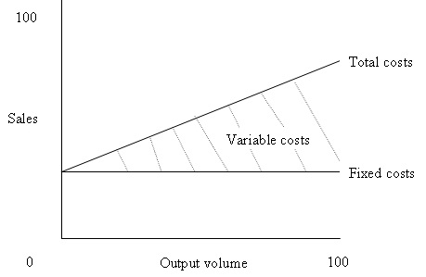
- Fixed costs are incurred and have to be paid regardless of the volume produced and sold. They are the costs of running a business such as heating, lighting, rent, insurance, marketing and so on.
Variable costs:
- In contrast, variable costs are directly related to the job and so change with the level of output. The best example of a direct cost is the raw materials that go into making a product.
Fixed costs plus variable costs are known as total costs:
Revenue:
This is the total amount of money coming in to a business from sales of goods or services. It is a ‘top-line’ figure that excludes deductions of tax, interest and dividend payments. It also usually excludes discounts for early payments and customer returns.
Profit:
This is often referred to as the ‘bottom-line’ and is the result of subtracting costs from total revenue. It can be expressed as gross profit which is revenue minus the variable cost of goods. It can also be expressed as net profit which also takes off the relevant amount for fixed costs, tax and so on. Profit is perhaps the most important indicator of how well a business doing.
Various calculations, or ratios, can be used to analyse the relationship between costs, revenue and profit. One would be the profit margin. This is found by dividing the profit figure into the revenue figure and allows you to see how well the company controls its costs to turn revenue into profit.
On the following page we will read an extensive case study of Cameron’s’ balloons. Take time to study the information thoroughly.
The Breakdown of a Balloon
Cameron Balloons produce a wide range of products. They are almost certainly best known for their conventional balloons, but even these come in a wide range. They range from a very small single person envelope that suspends a single-seater metal frame rather than a basket, to the huge envelopes used by commercial passenger carrying operations.
If you were thinking of buying a hot-air balloon, there are various bits you will need if you want to fly it. The example we have taken is a balloon model - Type 'N90' - one of the standard models which Cameron Balloons make.
This model would be suitable for sponsorship or advertising use. The total cost of the balloon is around R21, 885 (2000 price), but there are 3 major elements to this cost. These are the envelope, basket and burners.
However, you need more than just these three bits to go flying. Any attempt to hang an envelope over a basket and fire hot-air into it is sure to end in an embarrassing failure. A whole range of other odds and ends are needed to complete the picture. The links around the balloon below take you to the glossary section to give you further details on that particular item.
Envelope  R10440  Envelope scoop  R410  Padded covers (4)  R 196  Inflator fan  R 1120 |  |  | Artwork  Price - depends what you would like!  Shadow double burner  R 3420  Basket  R 2440  Fuel cylinders (4)  R 2348
Tether line (50m)  R 126 | Other equipment  R 264 | Cushion floor  R 176 | Instruments  R 945

Total Balloon Cost: R21885 (2000 price) (for a 3-4 person balloon). These prices refer to the low season which runs from 31 August to 1 Jan. In the high season an envelope will cost around R12, 220.

Explanation
The process of producing the balloons has a number of stages. Production starts with the design team passing on the detailed design of all the panels. This will often be in the form of templates that have been cut on the plotter.
The cutters then cut the cloth according to the templates. This is done on the cutting tables and as the cutters pull the cloth from the reels, it is drawn in front of large lights. This is to try to spot any imperfections in the cloth. It is much cheaper to correct these at this early stage, than to re-build a finished balloon!
The cut panels are then passed on to a team of sewers. A team is usually made up of around 5 machinists with a team leader. This team will usually follow through the production of the whole envelope. They sew all the panels together and sew in the tapes that carry the loads of the balloon down to the stainless steel frame around the basket.
The artwork will be put onto the balloon either before or after this stage. Sometimes the artwork may be dyed into the fabric before sewing using a dye-sublimation technique (this is done by outside contractors); though more often it is done by the artwork department at Cameron's. Sometimes it is airbrushed on and sometimes it is stuck on.
Meanwhile, all the rest of the balloon has to be produced as well. There is the basket, the burners and all the rigging to be done, as well as many of the ancillary items. The baskets are made by an outside contractor but finished by Cameron's. This means putting on the padding and fitting all the internal pieces. Finally it is all put together by the engineering department, and passed over to the lucky customer.
Theories
There are various theories about production that it may be helpful to know when considering the way Cameron Balloons produce their product. Production of balloons is a very different activity to mass production of consumer items.

Job / Batch / Flow Production
Job production - this is a method of production where companies use all their factors of production to complete one job at a time. This will usually happen where products are all unique or they are being produced on a very small scale.
Batch production - this is a method of production where one operation is completed on a number of units of the product, before they are then passed on to the next stage of the process.

Flow production - this is where production takes place as a continuous process. The product flows from one process onto the next. This will usually happen where the product is standardised, and can be made using a production line method.

Labour / Capital Intensive
Labour intensive - this is where the proportion of labour used in producing the product is relatively high. Labour will usually be used instead of capital. Capital intensive - this is where techniques are used to produce items that use relatively more capital than labour. Many industries are now like this including the car and steel industries.
The technique that a company uses depends on several things:
- The size of the company - small companies are often not in a position to afford expensive capital equipment. Even if they could they are often not able to use it enough to justify the cost.
- The cost of the factors of production - even though a machine may be available to do the job, it may not be worthwhile if the amount of labour required costs less. Firms therefore look carefully at the cost of labour and capital before deciding how much to use.
- The product - some products lend themselves better to being produced by capital than others. Mass-produced everyday items are far more likely to be produced in a capital-intensive way, whereas services
Costs
The firm incurs a variety of costs when it produces and we split these in various ways. One way is to split them into fixed costs and variable costs:
- Fixed costs - these are costs that do not vary as the level of production varies. These include such things as rent, business rates and security costs.
- Variable costs - these are costs that do vary as output varies and so will include things like raw materials, labour costs and energy costs and so on.
Another very similar way to split costs is into direct costs and indirect costs:
- Direct costs - these are similar to variable costs, and are costs that can be directly attributed to the production of each unit of the good. This will therefore be things like the cost of the raw materials, the packaging, the labour time that went into the production (if that can be clearly identified) and so on.
- Indirect costs - these are more commonly known in practice as overheads, and are general costs that are not specifically related to the product. They may be things like marketing and distribution costs, the cost of secretarial staff, the cost of the premises (rent and so on) and general bills like phone bills.
Efficiency
It is vital to a company to ensure they are efficient. Although Cameron Balloons is the clear leader in the hot-air balloons market, it is nevertheless a very competitive market and has suffered in the past from 'over capacity'. They therefore have to keep a careful eye on how their costs compare. One of the ways they may do this is to look at the level of average costs. The average cost is calculated as follows:
Average Cost = $\frac{Total cost}{Output}$

This gives the cost per unit of production, and so one measure of efficiency. Another measure would be to look at how much each particular factor of production (labour / capital / land) manages to produce. In this way we can measure productivity. For example to calculate labour productivity:
Labour Productivity = $\frac{Output \left(in a certain time\right)}{Number of employees (during the same time)}$

This can be a useful measure but does need careful interpretation. For example, who exactly do you include - all employees, or just those directly involved in production? You also have to ensure that you always calculate it consistently or it will be very difficult to draw useful conclusions.
Once you have studied the information above, discuss the questions in your groups and then prepare to give the rest of your class feedback on your findings.
- Would you classify the production of balloons as capital-intensive or labour-intensive? Give reasons for your answer.
- What are the main factors that affect the decision of a manufacturing company about where to locate?
- Which of these might be particularly important in the case of Cameron Balloons?
- Bloemfontein has become perhaps the ballooning capital of South Africa. Why is it important for Cameron's to be located there?
The fabric for the balloon envelopes is currently cut on cutting tables by hand. There are now moving-bed cutters available that will automate this process, and cut the fabric according to computer templates. There are two main types of cutter - one uses a high powered water jet to cut the fabric and the other a laser.
- What advantages might there be from using these new machines?
- What disadvantages might there be?
The costs of making a balloon split between direct and indirect costs. For standard balloons, there is little in the way of design costs and the production costs will be a greater share of the price. However, for special shape balloons there is clearly a considerable amount of time goes into the planning and design of the product.
- What is meant by the term direct costs?
- What is meant by the term indirect costs?

The cost of running a business
When you are asked about the hourly cost to run your business, the first thing you might think is what your hourly pay rate is. Someone in retail may think this is enough. Many people who run service businesses don't think in terms of hourly cost.
Unfortunately, to run your business you need to know this information to understand where your break even cost is going to be - this is the minimum charge you must have per customer to maintain your business. There is a simple formula which can easily determine the hourly rate to keep the business open.
The formula below uses four parts to come up with the hourly cost to run your business:
$\frac{Your pay+Your overheads+Your Profit Margin}{Working Hours}$= Your Hourly Cost

We'll look at each part of the formula so you can understand why you need to know that number. Use a weekly average for each number to get the hourly cost.
Pay
This is the hourly cost to pay yourself to run your business, or what you would pay an employee to do your job. This number could be based on what you made at previous employment before opening your business, or it could be based upon industry standards. This is the number needed to pay personal expenses and bills each week.
Overhead
This is the amount needed to keep your business running properly. To find the hourly cost of your business overhead, you will need other numbers. Some of the numbers to include would be cost of utilities, taxes, insurance, maintenance, fuel, Internet access, and any other expense for items which are used on a near daily basis to maintain your operation.
Profit Margin
Profit margins are the amount above basic operating costs to build revenue. Figuring your profit margin is accomplished by using a percentage, which is is based upon the sum of the previous two items above. To find the hourly cost to run your business profitably you need to take your hourly pay plus your overhead, then divide that by a percentage to find a number for your profit margin.
We'll use a contractor job as an example. If I wanted to earn R15 per hour, and a job took me an hour to finish, I'd make R15. The supplies I used to do the job would include materials, gas, permits, insurance, and so on. Let's use R50 to cover overhead for the job. It looks like this: R15 + R50 = R65. If I want a 20% profit I would take 20% of 65 which is 13 – this would give a profit of R13 per hour.

Working Hours
To find the hourly cost to run your business you will also need your hourly pay; but you also need to calculate an approximate number of hours of work each week. You need a best guess for an average work week to “be” at your business.
Let's plug in numbers to show how the formula works.
- We'll go back to the contractor job at R15 per hour at 40 hours a week. This gives us R600 per week.
- Use the overhead cost estimate from above of R50 per hour and do the same math (50 x 40 = R2,000 per week).
- Take the R13 per hour profit and do the same thing (13 x 40 = R520).
- Add the totals (600 + 2,000 + 520 = 3,120).
- Divide the total by the number of hours worked (3,120 / 40 = 78).
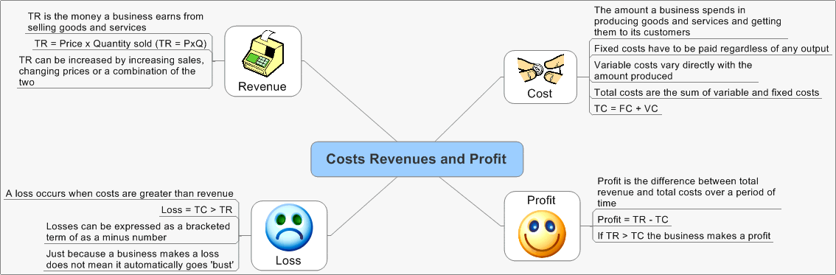
- You would need R78 per hour to run a profitable business in this example. You can use this formula for any business.
Let’s take a look at an example:
A small superette bakes rye bread and sells it for R12 per loaf. It costs the company R7 per loaf to produce the bread, and the company has to add an additional R1.20 in tax.
Determine the superette’s profit margin on the rye bread; correct it to one decimal place
Profit margin = $\frac{net income}{net sales revenue}$
= $\frac{R3.80}{12}$ (R12 – R7 – R1.20) = R3.80
= 31.7%
The bakery down the road from the superette sells rye bread at R10.50 per loaf. It costs the bakery R6.30 per loaf to produce the bread plus the additional R1.20 in tax. Which company makes more profit on their rye bread, give a reason for your answer.
Profit margin = $\frac{net income}{net sales revenue}$
= $\frac{R3.00}{R10.50}$ (R10.50 – R6.30 – R1.20) = R3.00
= 28.57% ≈ 28.6%
The superette makes a higher profit on its rye bread

Explain how the company with the lower profit margin can adjust its pricing to make the same profit as it’s’ competitor.
Production costs and the tax of R1.20 cannot be changed. The bakery will have to sell its rye bread at a higher price to increase its profit margin.

Activity - In Pairs
Use the same scenario as above, answering the same questions, but in the following instances:
Situation 1 – Prices in the superette franchise has gone up by 15%, while the bakery’s franchise prices was only inflated by 13.5%; and the tax has risen by 1%. Calculate the same scenarios as above, after making the changes given.
1 -A small superette bakes rye bread and sells it for R per loaf. It costs the company R7 per loaf to produce the bread, and the company has to add an additional R in tax.
Determine the superette’s profit margin on the rye bread; correct it to one decimal place

The bakery down the road from the superette sells rye bread at R per loaf. It costs the bakery R6.30 per loaf to produce the bread plus the additional R in tax. Which company makes more profit on their rye bread, give a reason for your answer.

Explain how the company with the lower profit margin can adjust its pricing to make the same profit as it’s’ competitor.

Situation 2 – Prices in the superette franchise has gone up by 15%, while the bakery’s franchise prices was only inflated by 13.5%; and the tax has risen by 1%. Calculate the same scenarios as above, after making the changes given.
2 -A small superette bakes rye bread and sells it for R per loaf. It costs the company R8 per loaf to produce the bread, and the company has to add an additional R in tax.
Determine the superette’s profit margin on the rye bread; correct it to one decimal place
The bakery down the road from the superette sells rye bread at R per loaf. It costs the bakery R9.30 per loaf to produce the bread plus the additional R in tax. Which company makes more profit on their rye bread, give a reason for your answer.

Explain how the company with the lower profit margin can adjust its pricing to make the same profit as it’s’ competitor.

Session 4  SO 4 | Use mathematics to debate aspects of the national and global economy.
Learning Outcomes  (Assessment Criteria) | - Values are calculated correctly.  - Mathematical tools and systems are used effectively to determine, compare and describe aspects of the national and global economy.  - Debating points are based on well-reasoned arguments and are supported by mathematical information.

Maths and our world…who said Maths is not beautiful?
9 x 9 + 7 = 88
98 x 9 + 6 = 888
987 x 9 + 5 = 8888
9876 x 9 + 4 = 88888
98765 x 9 + 3 = 888888
987654 x 9 + 2 = 8888888
9876543 x 9 + 1 = 88888888
98765432 x 9 + 0 = 888888888
1 x 8 + 1 = 9
12 x 8 + 2 = 98
123 x 8 + 3 = 987
1234 x 8 + 4 = 9876
12345 x 8 + 5 = 98765
123456 x 8 + 6 = 987654
1234567 x 8 + 7 = 9876543
12345678 x 8 + 8 = 98765432
123456789 x 8 + 9 = 987654321

1 x 1 = 1
11 x 11 = 121
111 x 111 = 12321
1111 x 1111 = 1234321
11111 x 11111 = 123454321
111111 x 111111 = 12345654321
1111111 x 1111111 = 1234567654321
11111111 x 11111111 = 123456787654321
111111111 x 111111111=12345678987654321

1 x 9 + 2 = 11
12 x 9 + 3 = 111
123 x 9 + 4 = 1111
1234 x 9 + 5 = 11111
12345 x 9 + 6 = 111111
123456 x 9 + 7 = 1111111
1234567 x 9 + 8 = 11111111
12345678 x 9 + 9 = 111111111
123456789 x 9 +10= 1111111111

Activity – On Your Own
Look at the pictures below, think of numbers and describe how you can see numbers ineach of them:

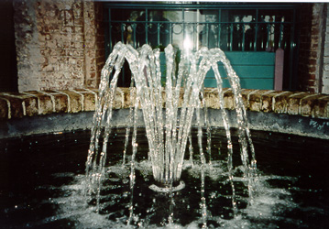
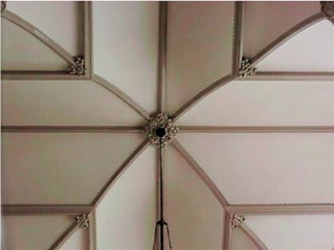
Fibonacci asked, “How many pairs of rabbits will there be after one year?” The diagram shows the results of the first six months.
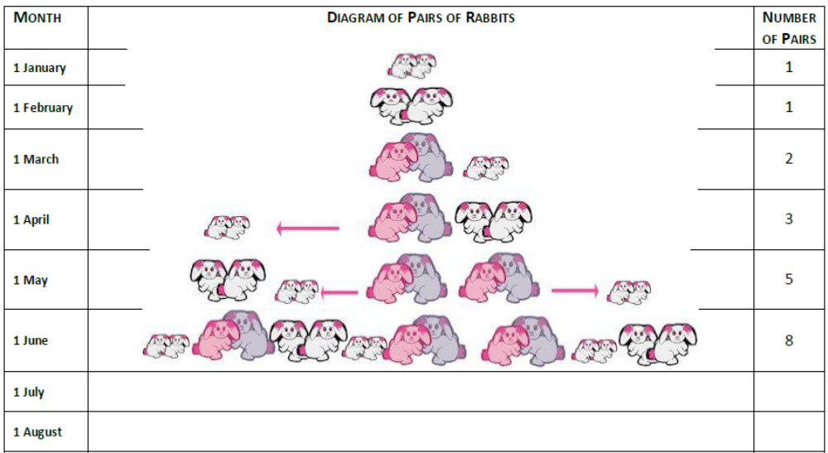

Interest
Earlier simple interest and compound interest were studied. If you master the techniques in this section, when you start working and earning you will be able to apply the techniques in this chapter to critically assess how to invest your money.
And when you are looking at applying for a bond from a bank to buy a home, you will confidently be able to get out the calculator and work out with amazement how much you could actually save by making additional repayments.
Indeed, this section will provide you with the fundamental concepts you will need to confidently manage your finances and with some successful investing, sit back on your yacht and enjoy the millionaire lifestyle.
Finding the Length of the Investment or Loan
Previously, we used the Compound Interest formula A = P (1 + i) n to determine the term of the investment or loan, by trial and error. Remember that P is the initial amount, A is the current amount, i is the interest rate and n is the number of time units (number of months or years).

So if we invest an amount and know what the interest rate is, then we can work out how long it will take for the money to grow to the required amount. Now that you have learnt about logarithms, you are ready to work out the proper algebraic solution.

The basic finance equation is: A = P x(1 + i) n
Solving for n:
A = P(1 + i)^{n}
(1 + i)^{n} = (A/P)
log((1 + i)^{n}) = log(A/P)
n log(1 + i) = log(A/P)
n = log(A/P)/ log(1 + i)
Remember, you do not have to memorise this formula. It is very easy to derive any time you need it. It is simply a matter of writing down what you have, deciding what you need, and solving for that variable.
Let’s take a look at an example:
Question: Suppose we invested R3 500 into a savings account which pays 7, 5% compound interest. After an unknown period of time our account is worth R4 044, 69. For how long did we invest the money? How does this compare with the trial and error answer from Chapters?
Answer
Step 4 : Determine what is given and what is required
• P=R3 500
• i=7,5%
• A=R4 044,69
We are required to find n.
Step 5 : Determine how to approach the problem
We know that:
A = P(1 + i)n
(1 + i)n = (A/P)
log((1 + i)n) = log(A/P)
n log(1 + i) = log(A/P)
n = log(A/P)/ log(1 + i)
Step 6 : Solve the problem
n = log(A/P)/ log(1 + i)
=log$\frac{\left(\frac{4044.69}{3500}\right)}{\log{(1+0.075)}}$Remember that:7.5% =$\frac{7.5}{100}$ = = 0.075
= 2.0
Step 7 : Write final answer
The R3 500 was invested for 2 years.

A Series of Payments
By this stage, you know how to do calculations such as ‘If I want R1 000 in 3 years’ time, how much I need to invest now at 10%?’What if we extend this as follows: ‘If I want to draw R1 000 next year, R1 000 the next yearand R1 000 after three years ... how much do I need to initially put into a bank account earning10% p.a. to be able to afford to be able to do this?’

The obvious way of working that out is to work out how much you need now to afford the payments individually and sum them. We’ll work out how much is needed now to afford the payment of R1 000 in a year (= R1 000 ×(1,10)−1 = R909,09), the amount needed now for the following year’s R1 000 (= R1 000 × (1,10)−2 = R826,45) and the amount needed now for the R1 000 after 3 years (= R1 000 × (1,10)−3 = R751,31). Add these together gives you the amount needed to afford all three payments and you get R2 486, 85.
So, if you put R2 486,85 into a 10% bank account now, you will be able to draw out R1 000 ina year, R1 000 a year after that, and R1 000 a year after that - and your bank account will comedown to R0. You would have had exactly the right amount of money to do that (obviously!).
You can check this as follows:
Amount at Time 0 (i.e. Now) = R2 486, 85
Amount at Time 1 (i.e. a year later) = 2 486, 85(1+10%) = R2 735, 54
Amount after withdrawing R1 000 = 2 735, 54 - 1 000 = R1 735, 54
Amount at Time 2 (i.e. a year later) = 1 735, 54(1+10%) = R1 909, 09
Amount after withdrawing R1 000 = R1 909, 09 - 1 000 = R909, 09
Amount at Time 3 (i.e. a year later) = 909, 09(1+10%) = R1 000
Amount after withdrawing R1 000 = 1 000 - 1 000 = R0
Perfect! Of course, for only three years, that was not too bad. But what if we asked you how much you needed to put into a bank account now, to be able to afford R100 a month for the next 15 years. If you used the above approach you would still get the right answer, but it would take you weeks!
There is an easier way! This section will focus on describing how to work with:
- Annuities - a fixed sum payable each year or each month, either to provide a pre-determined sum at the end of a number of years or months (referred to as a future value annuity) or a fixed amount paid each year or each month to repay (amortise) a loan (referred to as a present value annuity).
- Bond repayments - a fixed sum payable at regular intervals to pay off a loan; this is an example of a present value annuity.
- Sinking funds - an accounting term for cash set aside for a particular purpose and invested so that the correct amount of money will be available when it is needed. This is an example of a future value annuity.
Sequences and Series
The simplest type of numerical sequence is an arithmetic sequence. Definition: Arithmetic Sequence is an arithmetic (or linear) sequence is a sequence of numbers in which each new term is calculated by adding a constant value to the previous term.
For example,1, 2, 3,4,5,6… is an arithmetic sequence because you add 1 to the current term to get the next term:
First term: 1
Second term: 2=1+1
Third term: 3=2+1
n^{th}term: n = (n − 1) + 1
Activity – On Your Own
Common Difference: Find the constant value that is added toget the following sequences and write out the next 4 terms.
1. 2 6 10 14 18 22
2. −5 − 3 − 1 1 3 5
3. 1 4 7 10 13 16
4. −1 10 21 32 43 54
5. 3 0 − 3 − 6 − 9 − 12
More formally, the number we start out with is called a1 (the first term), and the difference between each successive term is denoted d, called the common difference. The general arithmetic sequence looks like:
a1 = a1
a2 = a1 + d
a3 = a2 + d = (a1+d) + d = a1 + 2d
a4 = a3 + d = (a1 + 2d) + d = a1 + 3d…
an = a1 + d x (n – 1)
Thus the equation for the n^{th} –term will be:
an = a1 + d x (n-1)
Given a1 and the common difference, d, the entire set of numbers belonging to an arithmetic sequence can be generated.
Definition: Arithmetic Sequence
An arithmetic (or linear) sequence is a sequence of numbers in which each new term is calculated by adding a constant value to the previous term:
an = an−1 + d (3.2)
Where
- an represents the new term, the nth-term, that is calculated;
- an−1 represents the previous term, the (n − 1)^{th}-term;
- d represents some constant.
Test for Arithmetic Sequences
A simple test for an arithmetic sequence is to check that the difference between consecutive terms is constant:
a2 − a1 = a3 − a2 = an − an−1 = d (3.3)
This is quite an important equation, and is the definitive test for an arithmetic sequence. If this condition does not hold, the sequence is not an arithmetic sequence.
Geometric Sequences
Definition: Geometric Sequences - A geometric sequence is a sequence in which every number in the sequence is equal to the previous number in the sequence, multiplied by a constant number. This means that the ratio between consecutive numbers in the geometric sequence is a constant.
We will explain what we mean by ratio after looking at the following example.
A Flu Epidemic
Extension: What is influenza?
Influenza (commonly called “the flu”) is caused by the influenza virus, which infects the respiratory tract (nose, throat, lungs). It can cause mild to severe illness that most of us get during winter time. The main way that the influenza virus is spread is from person to person in respiratory droplets of coughs and sneezes. (This is called “droplet spread”.) This can happen when droplets from a cough or sneeze of an infected person are propelled (generally, up to a metre) through the air and deposited on the mouth or nose of people nearby. It is good practise to cover your mouth when you cough or sneeze so as not to infect others around you when you have the flu.
Assume that you have the flu virus, and you forgot to cover your mouth when two friends came to visit while you were sick in bed. They leave, and the next day they also have the flu. Let’s assume that they in turn spread the virus to two of their friends by the same droplet spread the following day. Assuming this pattern continues and each sick person infects 2 other friends, we can represent these events in the following manner:
Day, n | Number of newly-infected people
1 | 2 = 2
2 | 4 = 2 x 2 = 2 x 2¹
3 | 8 = 2 x 4 = 2 x 2 x 2 = 2 x 2²
4 | 16 = 2 x 8 = 2 x 2 x 2 x 2 = 2 x 2³
5 | 32 = 2 x 16 = 2 x 2 x 2 x 2 x 2 = 2 x 2⁴
… | …
n | = 2 x 2 x 2 x 2 x … x 2 = 2 x 2^{n-1}

Again we can tabulate the events and formulate an equation for the general case: Each person infects two more people with the flu virus.
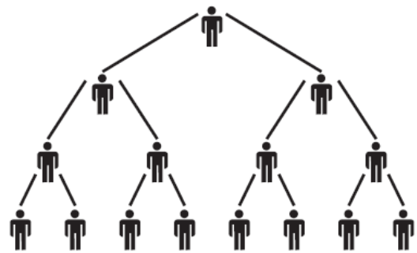
The above table represents the number of newly-infected people after n days since you first infected your 2 friends.
You sneeze and the virus is carried over to 2 people who start the chain (a1 = 2).

The next day, each one then infects 2 of their friends. Now 4 people are newly-infected. Each of them infects2 people the third day, and 8 people are infected, and so on.
These events can be written as a geometric sequence:
2; 4; 8; 16; 32; . . .
Note the common factor (2) between the events. Recall from the linear arithmetic sequence how the common differences between terms were established. In the geometric sequence we can determine the common ratio, r, by
$\frac{a2}{a1}$ = $\frac{a3}{a2}$ = r
Or a more general way
$\frac{an}{an-1}$

Activity – On Your Own
Common Factor of Geometric Sequence: Determine the common factor for the following geometric sequences:
1. 5 10 20 40 80
2.$\frac{1}{2}$ $\frac{1}{4}$ $\frac{1}{8}$ $\frac{1}{16}$ $\frac{1}{32}$
3. 7 28 112 448
4. 2 6 18 54
Present Values of a series of Payments
So having reviewed the mathematics of Sequences and Series, you might be wondering how this is meant to have any practical purpose! Given that we are in the finance section, you would be right to guess that there must be some financial use to all this. Here is an example which happens in many people’s lives - so you know you are learning something practical.
Let us say you would like to buy a property for R300 000, so you go to the bank to apply fora mortgage bond. The bank wants it to be repaid by annually payments for the next 20 years, starting at end of this year. They will charge you 15% interest per annum. At the end of the 20years the bank would have received back the total amount you borrowed together with all the interest they have earned from lending you the money. You would obviously want to work out what the annual repayment is going to be!
Let X be the annual repayment, i is the interest rate, and M is the amount of the mortgage bond you will be taking out. Time lines are particularly useful tools for visualizing the series of payments for calculations, and we can represent these payments on a time line as:
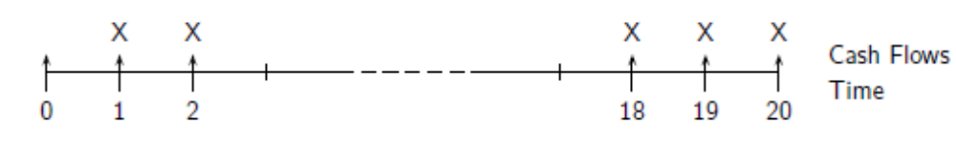
The present value of all the payments (which includes interest) must equate to the (present)value of the mortgage loan amount. Mathematically, you can write this as:
M = X (1+i)⁻¹ +X (1+i)⁻² +X (1+i)⁻³+X (1+i)⁻⁴+X (1+i)⁻⁵+… X (1+i)⁻²⁰
The painful way of solving this problem would be to do the calculation for each of the terms above - which is 20 different calculations. Not only would you probably get bored along the way, but you are also likely to make a mistake.
Naturally, there is a simpler way of doing this! You can rewrite the above equation as follows:
M = X [v¹ + v² + v³ + ... + v²⁰]
Where v^{i} = (1 + i)⁻¹ = 1/(1 + i)
Of course, you do not have to use the method of substitution to solve this. We just find this a useful method because you can get rid of the negative exponents - which can be quite confusing! As an exercise - to show you are a real financial whizz - try to solve this without substitution. It is actually quite easy.
Now, the item in square brackets is the sum of a geometric sequence, as discussed earlier. This can be re-written as follows,
v¹ + v² + v³ + … + v^{n} = v (1 + v + v² + … + v^{n-1})
= v ($\frac{1-v^{n}}{1-v}$)
= $\frac{1- v^{n}}{1/v-1}$
= $\frac{1-(1+i)^{-n}}{i}$
Note that we took out a common factor of v before using the formula for the geometric sequence. So we can write:
M = X [$\frac{(1-(1+i)^{-n})}{i}$]
This can be rewritten:
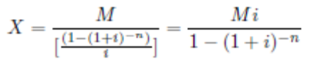
So, this formula is useful if you know the amount of the mortgage bond you need and want to work out the repayment, or if you know how big a repayment you can afford and want to see what property you can buy.
For example, if I want to buy a house for R300 000 over 20 years, and the bank is going to charge me 15% per annum on the outstanding balance, then the annual repayment is:
X = $\frac{Mi}{1-(1+i)^{-n}}$
= $\frac{R300 000 x 0.15}{1-(1+0.15)^{-20}}$
= R4 792 844
This means, each year for the next 20 years, I need to pay the bank R47 928, 44 per year beforeI have paid off the mortgage bond.On the other hand, if I know I will only have R30 000 a year to repay my bond, then how big ahouse can I buy? That is easy…
M = X [$\frac{(1-(1+i)^{-n})}{i}$]
= R30 000 $\frac{(1-(1.15)^{-20}}{0.15}$
= R187 779, 90
So, for R30 000 a year for 20 years, I can afford to buy a house of R187 800 (rounded to thenearest hundred).
The bad news is that R187 800 does not come close to the R300 000 you wanted to pay! The good news is that you do not have to memorise this formula.

Worked Example: Monthly mortgage repayments
Question: Sam is looking to buy his first flat, and has R15 000 in cash savings which he will use as a deposit. He has viewed a flat which is on the market for R250 000, and he would like to work out how much the monthly repayments would be. He will be taking out a 30 year mortgage with monthly repayments. The annual interest rate is 11%.

Step 1: Determine what is given and what is needed
The following is given:
- Deposit amount = R15 000
- Price of flat = R250 000
- Interest rate, i = 11%
We are required to find the monthly repayment for a 30-year mortgage.

Step 2: Determine how to approach the problem
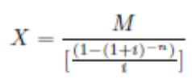
We know that:

In order to use this equation, we need to calculate M, the amount of the mortgage bond, which is the purchase price of property less the deposit which Sam pays up-front.
M = R250 000 − R15 000
= R235 000
Now because we are considering monthly repayments, but we have been given an annual interest rate, we need to convert this to a monthly interest rate, i12.
(1 + i12)¹² = (1 + i)
(1 + i12)¹² = 1, 11
i12 = 0,873459%
We know that the mortgage bond is for 30 years, which equates to 360months.

Step 3: Solve the problem
Now it is easy, we can just plug the numbers in the formula, but do notforget that you can always deduce the formula from first principles as well!
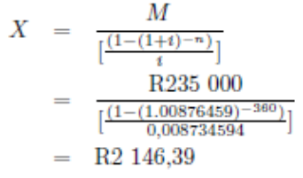
That means that to buy a flat for R250 000, after Sam pays a R5 000 deposit he will make repayments to the bank each month for the next 30 years, equal to R2 146, 39.
Answers to activities
Activity 1 – In Pairs
The following is a scenario of entrepreneurship of Poseletso. Read through the section and then answer the questions as you go along.
- Poseletso was given permission from the headmaster at her school to sell stationery to other learners, after school, in the school hall. Over the weekend she stocks upon blue pens, green pens, pencils, erasers, rulers and calculators. The table below shows how many of each item she purchases on average each month; complete the table by calculating the missing values in the last column:
Item | Number bought | Amount paid per item (R) | Total amount paid for items (R)
Blue pens | 100 | R 1, 50 | R 150.00
Green pens | 70 | R 1, 75 | R 122.50
Pencils | 150 | R 0,90 | R 135.00
Rulers | 25 | R 2,10 | R 52.50
Erasers | 50 | R 3, 70 | R 185.00
Calculators | 25 | R 89, 90 | R 2 247.50
- What is the total amount Poseletso plans on spending per month?
R 2 892.50
- To be able to afford this amount, she takes a loan of R3 500 from her father. Poseletso agrees to pay him back within one year with 7.5%simple interest added to the loan amount. How much money will Poseletso have to pay her father in a year’s time?
A = P (1 + in)
= 2 892.50 ($1+\frac{7.5}{100 }x 1)$
= 3 109.44
- Her sales for the for first four weeks are shown in the table below:
Item | Week 1 | Week 2 | Week 3 | Week 4 | Numbers sold p’month
Blue pens | 11 | 14 | 12 | 23 | 60
Green pens | 5 | 17 | 10 | 7 | 39
Pencils | 20 | 21 | 43 | 38 | 122
Rulers | 9 | 13 | 6 | 22 | 50
Erasers | 5 | 5 | 6 | 2 | 18
Calculators | 1 | 6 | 5 | 8 | 20
- Poseletso sells the stationery at the following unit prices:Which of the listed items should she buy fewer of per month to increase her profit margin? Motivate your answer.
Calculators, they are expensive and Poseletso does not sell them all in an average month.
- Calculate how much money would she have made after one month
60 x R2.00 = R120.00
39 x R2.00 = R78.00
50 x R4.00 = R200.00
122 x R1.50 = R183.00
18 x R3.00 = R57.00
20 x R100.00 = R2000.00
Total of R2 635.00
- Will she have made a profit after one month? Motivate your answer.
No, as she has spent more than she collected in the first month
- If the business is running for ten months of the school year, how much will Poseletso pay Lerato in that school year?
8 x R150.00 = R1 200
- Calculate the total amount of money Poseletso would have spent in the ten months of the school year.
(R2 892.50 x 10) + R 1 200.00 = R30 125.00
- Calculate the amount of money Poseletso would have made in these ten months of the school year.
R 2 635 x 10 = R26 350
- Did Poseletso make a profit at the end of the school year? Motivate your answer.
No, she did not make a profit. She spent far more than she has made and she has not paid her fathers’ money back yet.
- If Poseletso does not increase the prices of her items, but buys sufficient monthly stock for the requirements of her peers, will she make a profit or at least break even? Show all your calculations.
If Poseletso buys only the number of items her peers need on average, she will spend the following each month:
Item | Sold per month | Amount spent
Blue pens | 60 | R90.00
Green pens | 39 | R68.25
Pencils | 122 | R109.80
Rulers | 50 | R185.00
Erasers | 18 | R37.80
Calculators | 20 | R1 798.00
Total |  | R 2 288.85
Because she will spend this amount in the nine months following the first month when she collected the data, she would have spent (R2 288.85 x 9) + R 2 892.50 = R 23 492.15 in the ten months. She would receive the same amount of money at the end of the ten months, as her sales would not differ and her prices remained the same. This means that she would have still made R 26 350.00 at the end of the ten months. Poseletso needs to subtract the money that she owes her father (R3 109.44) from R 26 350.00. Therefore she will have this amount of money at the end of the year: R 26 350.00 – R 23 492.15 – R 3 109.44 = - R 251.59. Therefore she would not have made a profit.
- Suggest how Poseletso could have saved her business
She could have worked alone and/or increased her prices marginally as her products were selling.

Practise activities:
- Which of these two investments will yield the highest return if R10 000 is invested at simple interest? Show your calculations.
Deposit period (12 months) | Interest rate if the interest is paid monthly (10.2%) | Interest rate if interest is paid at the end of the period (10.65%)
 | SI = P x I x n  = 10000 x $\frac{10.20}{100}$ x $\frac{1}{12}$  = 85  So R85 x 12 months = R1 020 | SI = P x I x n  = 10000 x $\frac{10.65}{100}$ x 1  = 1 065  So R1 065

- Marco and Julia have just got engaged. They each have a lump sum which they want to invest, in order to make their funds grow sufficient for their wedding. However, they seem to disagree on who will get the best returns, as they cannot agree on which interest form to choose. So they decide to choose their own. Marco invests his R5 800 at 9% simple interest and Julia invests R4 700 at 11.75% simple interest annually. Who has the greater capital gain at the end of two years? Show your calculations.
Marco | Julia
A = R5 800 (1 + 0.09 x 2) = R6 844  So R6 844 - R5 800 = R 1 044 | A = R4 700 (1 + 0.1175 x 2) = R5 804.50  So R5 804.50 – R4 700 = R1 104.50

- Nkosi invested R7 000 at 4.5% simple interest 5 years ago, what is his capital worth now?
A = R7 000 (1 + 0.045% x 2) = R8 575

- Dorothy and Jane each got a lump sum from their Grandmother when they turned 18. Because they are identical twins, everybody expected them to go to university together, but Jane decided she wanted to get married to her high school sweet heart and set up house first and then pursue her academic career. After 7 years she decided to go and study, but she invested her amount (R10 675) at a fixed, simple interest rate of 6.25%. When she got her money, she wondered if she got the same amount as Dorothy’s R7 246.09 or not? Show your calculations.
A  10 675  10 675  $$\frac{10 675}{1.4375}$$  R7 246.09 | =  =  =  =  = | P (1 + in)  P (1 + $\frac{6.25}{100}$ x 7)  P (1.4375)  P  P
Activity 2 – In Pairs
The following is a scenario of Mpumi who wants to go and study. She has an offer to assist her in the payment of her studies, but she needs to consider her options. Let’s see how we can help her. Mpumi did well in her final examinations and therefore she has been offered a bursary.
The Department of Education has offered to pay her R10 000 per annum for her studies, as long as she works in the education sector for at least 6 years, after she has completed her studies. Here are the costs for the course that she wants to do:
Year | 1 | 2 | 3 | 4
Cost for lectures (ex VAT) | R 20 480.00 | R 22 528.00 | R 24 780.80 | R 25 524.22
Predicted cost for study material (ex VAT) | R 2 390.00 | R 2 509.50 | R 2 634.98 | R 2 714.03

Mpumi has invested R650, and she is earning 13% simple interest per year, what will her interest be after: (Remember to show your calculations)
- 4 years
I = Pin = 650 x $\frac{13}{100}$ x 4 = 338
The interest earned is R338
- 6 months
I = Pin = 650 x $\frac{13}{100}$ x $\frac{6}{12}$ = 42.25
The interest earned is R 42.25
- 2 years and 5 months
I = Pin = 650 x $\frac{13}{100}$ x $\frac{29}{12}$ = 204.21
The interest earned is R204.21
Back to Mpumi’s studies:
Calculate the percentage increase in lecture costs for all four years (excluding VAT).
Percentage increase between year 1 and 2:
% Increase = $\frac{difference in values}{original values}$ x 100%
= $\frac{22 528 - 20 480}{20 480}$ x 100%
= 10%
Percentage increase between year 2 and 3:
% Increase = $\frac{24 780.80- 22 528 }{22 528}$ x 100%
= 10%
Percentage increase between year 3 and 4:
% Increase = $\frac{25 524.22-24 780.80}{24 780.80}$ x 100%
= 3%

Calculate the percentage increase in study material costs for all 4 years (excluding VAT).
Percentage increase between year 1 and 2:
% Increase = $\frac{2 509.50-2 390}{2 390}$ x 100%
= 5%
Percentage increase between year 2 and 3:
% Increase = $\frac{2 634.98-2 509.50 }{2 509.50}$ x 100%
= 5%
Percentage increase between year 3 and 4:
% Increase = $\frac{2 714.03-2 634.98}{2 634.98}$ x 100%
= 3%

Discuss the general trend in cost increase for both the cost of lectures and the cost of her study materials.
The general percent increase for the lectures and the study material remains constant for the first three years, even though the lectures went up by 10% and the material by only 5%. In the last year, both categories only went up 3%

Calculate the cost for all four years that Mpumi has to pay herself.
Year | 1 | 2 | 3 | 4
Cost for lectures (ex VAT) | R 20 480.00 | R 22 528.00 | R 24 780.80 | R 25 524.22
Cost for lectures (inc VAT) | R 23 347.20 | R 25 681.92 | R 28 250.11 | R 29 097.61
Predicted cost for study material (ex VAT) | R 2 390.00 | R 2 509.50 | R 2 634.98 | R 2 714.03
Predicted cost for study material (inc VAT) | R 2 724.60 | R 2 860.83 | R 3 003.88 | R 3 093.99
Total cost per year | R 26 071.80 | R 28 542.75 | R 31 253.99 | R 32 191.60
Total cost after 4 years | R 118 060.14 – R 40 000 = R 78 060.14

Mpumi completes her studies and is appointed by the Education department. Her annual salary is R82 770.72. How much does Mpumi earn per month?
$\frac{R 82 779.72}{12 months}$ = R 6 897.56 per month

Mpumi uses 15% of her monthly salary to pay back her study loan, calculate how much money she pays back monthly.
R 6 897.56 x $\frac{15}{100 }$ = R 1 034.63: Mpumi pays back R 1 034.63
After how many months has Mpumi paid back her loan? And years?
$\frac{R 78 060.14}{R 1 034.63 p/month}$ = 75.447 months or 76 months, which means 6 years and 4 months
Do you think that it was worthwhile for Mpumi to take out the loan the education department offered? Motivate your answer.
Mpumi decided to pay back 15% of her salary towards the loan. The amount she has to pay back is reasonable and she pays the amount back for just over 6 years (which is the same amount of years she needs to work in education). After this time period she has no study debt and can peruse other career opportunities if she wishes to do so. Overall, her idea to take on the loan was a good idea.

